Child U is just 4 years old and lives in a Spanish-speaking household. He socialises well and responds to adult talk confidently.
Case studies from EAL Assessment Workshop July 2016
Child U
Nursery: Lambeth stage 3

Examples of spoken English:
“Can I eat it? It tastes like chocolate.”

“It getting bigger.”

“Mmmm it delicious.”

“My mummys got shampoo.”

Making a butterfly with salt dough. “I want to make a butterfly (sticks eyes on it) you eyes”.

Adult: “Can you see the queen bee? She has a white spot on her body.”
Child: “Where is the queen bee? Where is her crown?”

Looking at the carrots they have grown “It came from the ground …. we have to wash it because it was dirty.”

Child W
Nursery: Lambeth stage 2
Child W is 4 ½ years old and lives in a Bengali-speaking household. He can follow a story with pictures, but tends to lose focus in anything unsupported. He communicates well but is using his known vocabulary for unknown words ie rockets for rocks and not always with the correct meaning.

Examples of spoken English:
“Timer broken. J getting another one. A yellow one.”

Throwing ball. “You get it. Me now.”

Making butterfly with salt dough. “I make like this and this. Look eyes.”

Joins in with story refrains:
“Not I said the dog.”

Child X
Nursery: Lambeth stage 3

Child X has just turned 4 years old and lives in a Somali-speaking household. She responds well to instructions, but not as well to questions, especially in unfamiliar contexts. Has a tendency to lose focus when an adult uses long stretches of English. She forms marks in a line that represent letters and words and will ‘read’ them.

Examples of spoken English:

“Luke, I want to make a circle.”

“Let’s play Snap.”

“o, that’s in my name!”

“What is this one?”

“Look I wrote my name!”

Child B
Reception: Lambeth stage 3
The winnies took the prinses bi the feet then she poot her in a tool kasloo (tall castle) anD Graper (grandpa) was in a kath. (cave) anD traction man anD he sav the bai (day) hora for traction man traction man anD the prinses anD Graber has a fist anD kan you hav a slepoaver yes I well go to the perk les go to the swg.

Comments:
Her questioning when reading suggests that she is a reflective reader. She uses subject-specific vocabulary ie cone, cube, cylinder. Spoken and written language show good use of tenses including advanced past tense, appropriate pronouns, but with occasional word omissions.
Spoken:
“This box is my castle.”
“I’ve made a diamond castle.”
“Look I made a flower.”

Written:
some rats ate her tail.

Child D
Year 2: Lambeth stage 3.
Writing
Dear
This week we have been learning bout How to save the world I realise we to unplug the T.V.
It is important that we need to turn of the tap. It of then saves 18 of water. Did you know Corben diyoxiy is posenoise so walk to school. Another important this that we need to do is turn of the light. To save valbol light. This is important because our wirld set save. If we dont pick up rubbish floor you will get sick. Ples help us to save the world.
from
Reading
Spoken English:
Have you done Science recently?
“Hmmm We did Science today, about the Space Seeds. We did about the Space Seeds and we had to write what day they growed, the day they started germinating and um, the… then we wrote it down on the computer and then we sended it. Then we made some….then it was playtime.”
Very good at listening in class and absorbing what she hears for an age-appropriate length of time.
Very quiet when reading but can read fluently. She automatically sounds out unfamiliar words if she comes across them. She really enjoys reading, and often asks questions to discuss the meaning of words. She is currently reading ‘The Twits’ by Roald Dahl in class with support.

Writing
Child E
Year 1: Lambeth stage 2.

Formulating questions
13.4.16 who lifs ther?
is fun in ArntarticA?
wat is in ArntarticA?
Is evridei (every day) coad?

Retelling
once upon a mumi pig disktet three litel pigs leF the wm the 3 litewpigs go awei they biwi they hauwses
dfurst pig biwahes of schro a woof sed to the pig litewpig letmein No bai my ch I will Not letyou in den I will pufandpat and blowYouhowsdown

Translation
Once upon a mummy pig decided three little pigs left the home the 3 little pigs go away they built their houses the first little pig built a house of straw a wolf said to the pig little pig let me in No by my chin I will not let you in then I will puff and puff and blow your house down

Reads fluently, included suffix words, sounds out long unknown words. Can retell stories he has read, is animated and detailed in his retelling and uses language from the story. Links events in books he has read, and predicts what might happen next. He is currently reading blue books which are expected for Y1.
What were you just doing in class with your teacher?
“I just need to think a little bit... Pictures of coins, on a sheet, on a sheet of different ummm coins and…umm…and which coins Miss Smith says it is she give us first clues and, if you wait for the coin then we have it with the sheet…err.. if we have the coin and we can just put it on the sheet.”
(Children were playing money bingo)

Very good at listening in class and absorbing what he hears for an age appropriate length of time.

Child H
Year 3: Lambeth stage 2.
The mayor of Hamelin

the mayor prormised to get rid of the rats

they people was not happy when the rats was on there street nd they didn’t like it so the people get tid of discusting rats so the mayor said who can get rid of the rats and then he couldn’t the people feel happy that they said that.

the mayor found someone to get rid of the rats

the pied pier came to take the rats away he has a big hat and lots of the flun (?) and lots of it he took all the rats to the river.

the mayor lied to pied piper

and then the amazing pied piper when he comes back for he revenge.

sack gold

Child H continued

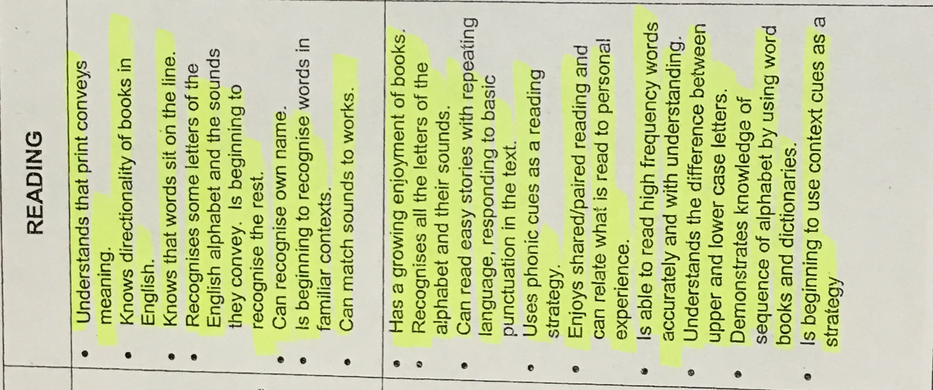

STAGE 2

Task: Writing own version of Cinderella changing some elements of story.
Child I
Year 3: Lambeth stage 3.

A long long time ago there was a prince called Anicon. He lived with his mother, stepfather and his two kind older brothers. He was treated badly he worked hard. After that his stepfather took his two older brothers.

When they got out of the beautiful house when they heard the enounsment. They got exitied to go and dance with the girls. Suddenly Anicon got upset and he cryed softly on his pilow. His stepfather didn’t by him any clothers to were. Then the fairy God mother came and she know that he wanted to dance with the girls she thliked her wand and she made him clothes to dance and the fairy God mother told him ”before midnight you have to come and you are going to turn back to normal”. He went to dance with the girls and …

Child I continued

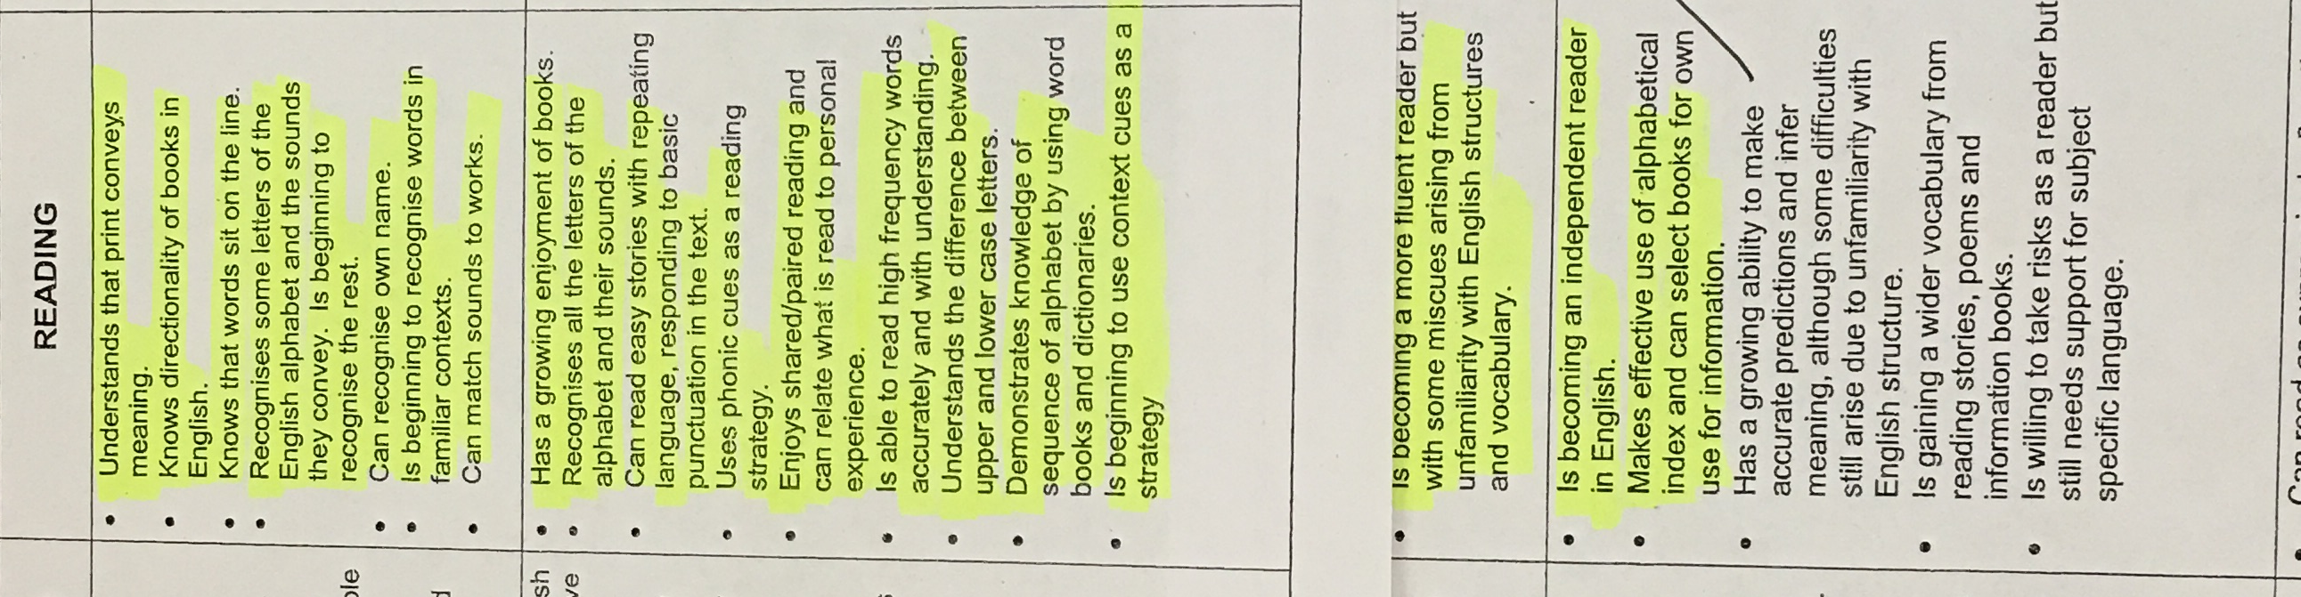

Stage 2

Stage 3

Child J
Year 3: Lambeth stage 2.
Task: Writing own version of Cinderella changing some elements of story

A long, long time ago in a small house lived a girl called Cinderella.
She lived with her dad, with her rued mum and two step sisters.
One day Cinderella, her mum and her step sister strolold though her wonderfull village. They herd the King said “there is going to be a ball.”
Cinderella really wan’ted to go but her mum said “No”.
Then Cinderella qickelly runed home criing with tirs.

The step sister got ready and there mum.
Her step sister and her mum went to the larage ball.
When they left Cinderella’s god mother came through the beautifull window and she magit up a dress.

Child J continued

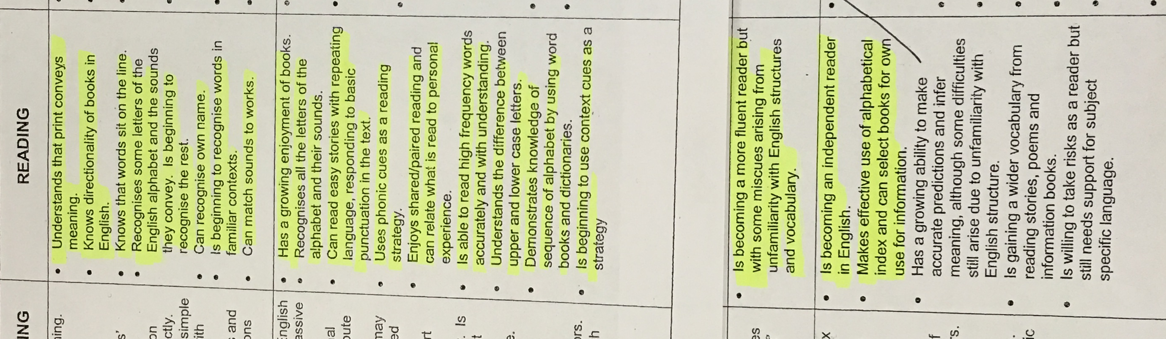

Stage 2

Stage 3

Can I create the first draft of my descriptive passage?
Child K
Year 5: Lambeth stage 3

He inattentively strolled across the ceaseless corridor not attempting to catch an eye of a harsh teacher.
“Why do I have to go to this boring councilors?” he muttered under his breath. “I did rather learn in Mrs Ebel class for an entire with no break than come here.”

As carried on with his journey (that was everlasting) he caught the eye a teacher of an unknown teacher.
“Bradely Chalkers!” she exclaimed
“What!” he rudely responded
Bradely was shocked at how many teachers knew his; everywhere he went everyone knew him even if he’d never seen them before.
“Why are you out of c.”
:I’ve got a hall pass; Mrs Ebel gave it to me, ask her if you don’t believe!” He aggressively interrupted.
“Very well,” she said embarrassed whilst storming of.

At the corner of his eye he noticed a open door. Inside it was an unlike-office messy room. It was the councilors office. There stood an elegant joyful woman. She had fair blonde and looked like she was the youngest teacher in the school.
Child K continued

“Hello you must be ..”
“Bradely Chalkers!” he rudely interrupted.
She held out her had waiting for Bradely to shake it.
She questioned him: “Are you going to shake my hand?”
“No, you’re to ugly!” he exclaimed he couldn’t control himself …
Boom! He slammed the door aggressively.

Child K continued

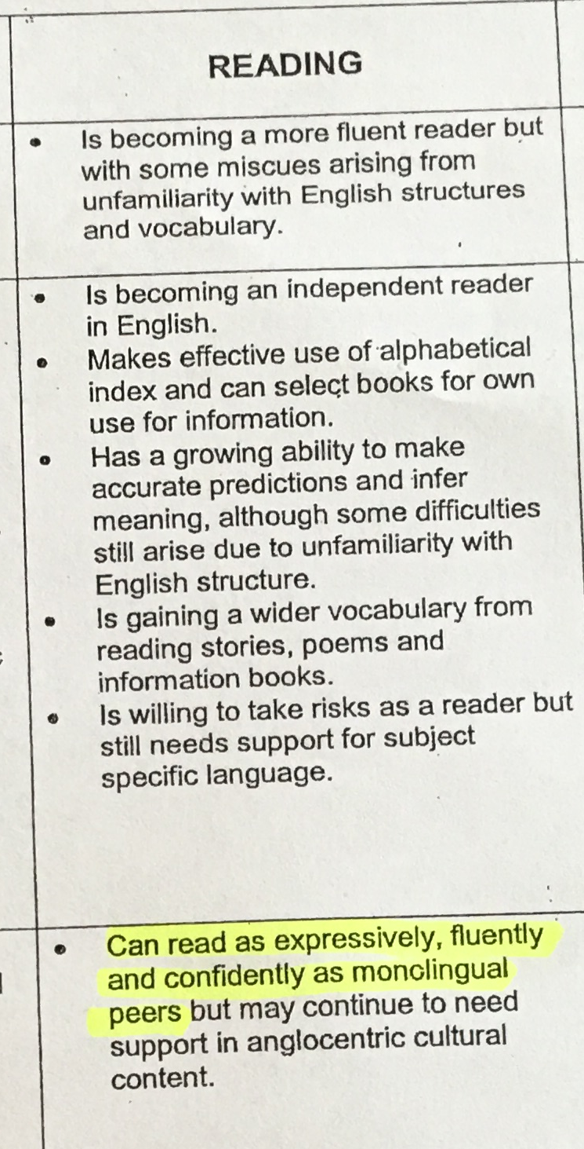
Stage 4

Nursery
Sample notes for nursery – these judgments were made in collaboration with the children’s teacher, which enabled consideration in the context wider that just the samples provided.

U | 3 | D | Using higher level language ie complex sentence ‘because’, comparative language. ‘bigger’. Mostly fluent occasional errors ie It/s, Good verbs we have to wash. Responds appropriately to adult speakers. Confident and articulate speaker, engages successfully across the curriculum.
W | 2 | B | Increasing confidence in expressing himself., but only in short clauses with words omitted. Uses a lot of deictic language supported by gesture and objects ie like this and this. Still mis-hearing new vocab and using known words, regardless of meaning, but beginning to use some topic-specific vocab ie timer. Joins in refrains from well-known stories.
X | 3 | C | Responds well to instructions but not so well to questions, suggests that her understanding is probably greater than her use of English. Instructions mostly relate to familiar contexts, whereas questions present the unfamiliar. Also loses track when extended talk from adult. Her English is mostly grammatically correct, she uses past tense and question forms and she is developing early literacy skills in line with her peers. Using some subject-specific vocab ie circle, Snap. Possibly the difficulties in engaging with wide range of input keep her as C rather than D, as curriculum demands increase.

Child | Old Lambeth  Stage | New code | Notes
Reception – Year 6 sample notes. These judgments have been made in collaboration with the child’s teachers, drawing on their wider knowledge of the child, as you would in the assessment process.

Reception
B | 3 | C | Spoken language and written language shows a range of tenses including irregular verbs. She uses pronouns appropriately and has developed a range of subject-specific vocabulary ie cone, cube, cylinder. Also she is using English prepositional phrases accurately ie ‘by the feet’ in writing. Only occasional grammatical errors, omitted ‘a’. When reading, her understanding and reflection is apparent in her questioning. Writing at length for a reception child, but turns into speech rather than narrative. Accurate oral grammar reflected in writing.
KS1
D | 3 | C | Spoken language in an academic area shows she is able to communicate thoughts and although beginning to use some subject-specific vocabulary, struggles with the complex sentences required to communicate fluently. Writes independently and has understood and retained letter genre. Shows some overall organisation and the variety of sentences starters support cohesion. Using simple punctuation, but more adventurous vocab ie realize, valuable. Attempting complex sentences, ie If we don’t … you will get, but there are grammatical errors and word omissions. Reading fluently and very aware of new vocabulary. Reflects as reads.
E | 2 | B | Reading at age-appropriate level with understanding. Away from familiar, struggles orally to communicate thoughts, both in terms of subject-specific vocab and also structures required. Starting to write independently using phonic knowledge, but is obviously a memorised retelling. Unaware of word boundaries ie letmein Inconsistent tenses, no punc. and word omissions. Difficulty with question form.
KS2

H | 2 | B | A confident Lambeth stage 2 reader – accurate decoder, but working at literal level.  Producing a small amount of independent writing, which is organized with sub-headings, but no punctuation. Mostly chained clauses and many grammatical errors – mixed pronoun she/his, difficulties with simple tenses and inconsistency. Quite limited vocabulary.
I | 3 | C | Has understood the task of changing the story. Story has been developed and organised through paragraphs and simple punctuation, although reverts to chained clauses at the end. Has an awareness of grammar - mostly accurate in terms of tenses, pronouns and word order and is beginning to develop through use of adjectives, occasional adventurous vocab. and phrases. The latter are not always accurate ie cryed softly on his pillow rather than into his pillow. Good spelling. However, some structural inaccuracies and limited to simple and compound sentences. Is becoming a fluent reader, although understanding still literal.
J | 2 | B | Prod small amount of independent writing, mostly using simple sentences. Hasn’t really understood task as hasn’t changed any element of the story. Occasional attempt to develop with descriptive vocabulary, but not always appropriate. Obvious structural difficulties. Becoming an independent reader, but understanding limited to literal.
K | 3 | D | Is reading on par with his English-only speaking peers, other than occasional queries with anglocentric cultural content. His writing has been developed with use of conversation, a range of descriptive devices and punctuation and definite attempts to hook the reader in. He has been adventurous in his use of vocabulary, not only adjectives but also precise verbs ie strolled, muttered, storming, although these are not always used in an appropriate context. There are occasional errors with structure, but he has used a range of sentence types, including advanced subordinators - whilst and adverbial clauses including those that front sentences.

