Guidance notes for importing the First Language codes into SIMS .net

Download the file “First Language Special Main Codes SIMS.zip”

Unzip the files to a particular directory for example: S:\First Languages

Log into SIMS with an account that has administration rights

1) Select Tools | Lookups | Import Lookups

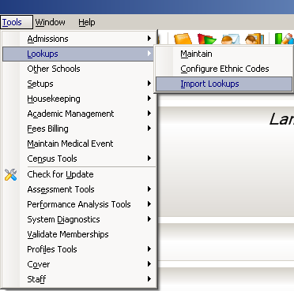

2) Click the Select File to find the file

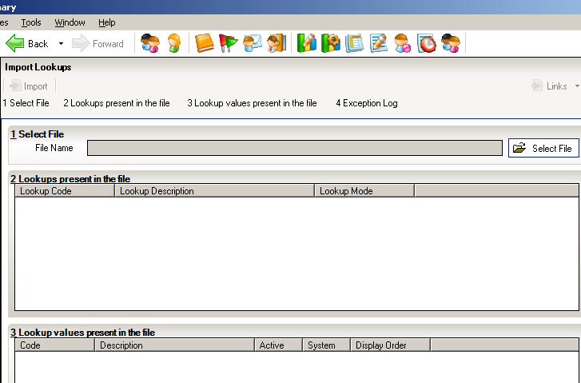
Select File button

- Browse to the correct folder
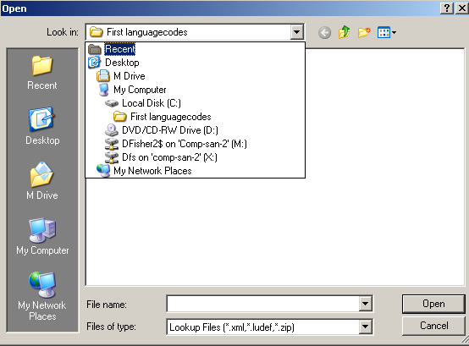

4) Click the file “1stLanguagespecialmain”

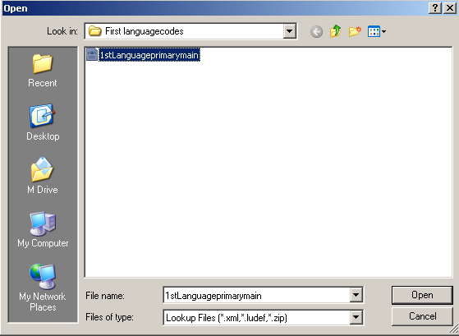

5) Click Open

6) Click the Import button

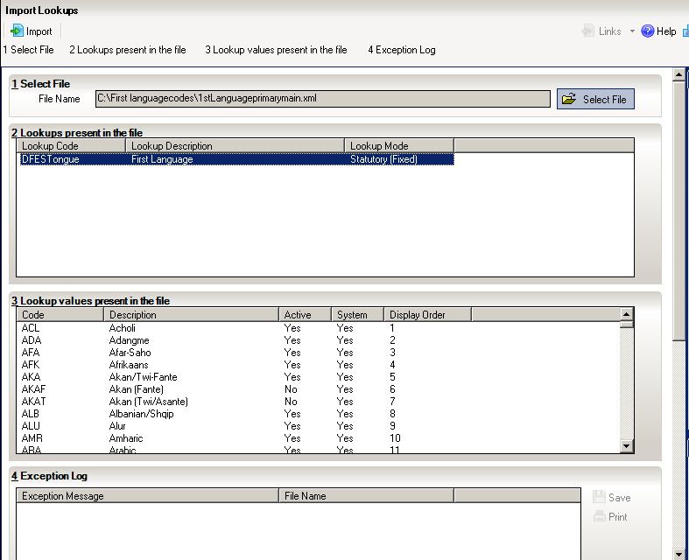

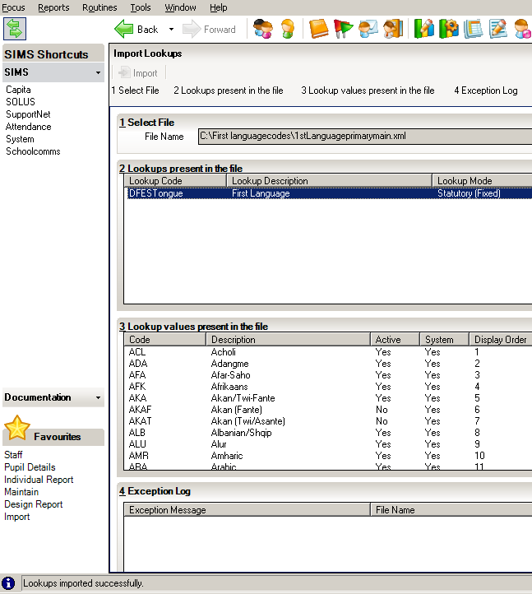

7) When complete the phrase “Lookups imported successfully.”

If you experience any difficulties importing this file please contact your SIMS support agency.

