Moderation of Proficiency in English in Lambeth Schools 2017

Introduction

This report summarises the findings from the 2017 moderation of the assessment of English as an Additional Language (EAL) in Lambeth schools and offers advice to ensure consistent practice across schools. Their welcome, cooperation and suggestions for improving practice not only facilitated the moderation exercise but also contributed to the content of this paper.

From the Spring term of 2017, it has been mandatory for schools to identify children developing English as an Additional Language in Reception classes and above and also to assign a stage of English proficiency using the DfE’s 5-point Proficiency Scale for the School Census. Lambeth has a long tradition of assessing English proficiency through the Lambeth Stages of English and with the support of introductory workshops in the summer term of 2016, schools have successfully made the transition to the new scale.

The accurate identification and assessment of a child developing EAL is essential not only for the purpose of the school grant allocation and data analysis, but also to inform teaching and learning within the school. It enables teachers to investigate underachievement, support the identification of SEN and high achievers and can be used to inform planning and teaching, as EAL development has to take place across and within the curriculum. The stages of English proficiency should be used to support target setting and next steps for developing a child’s English language. Moderation supports schools in doing this and also ensures that Lambeth Education Research and Statistics have reliable data with which to complete analysis, comment on trends and write reports for schools. This is also commensurate with moderation of FS, KS1 and KS2 assessment in schools.

Proficiency in English Outcomes

As in previous years a moderation of schools’ assessments has been completed, but with a focus on the DfE Proficiency in English Scale. Schools welcomed the opportunity for discussion on both assessment and on supporting pupils with EAL.

Analysis of the new DfE Proficiency in English of EAL pupils collected from all Lambeth Schools in the Spring 2017 School Census, shows the expected trend, similar to previous years’ collections using the Lambeth Stages of Fluency (Fig 1). Pupils with EAL in the nursery phase are predominantly New to English (A) or Early Acquisition (B). As pupils with EAL progress through primary school, most are Developing Competence in English (Stage C). By the time they reach secondary school, well over half of all pupils with EAL are Fully Fluent (Stage E). This would suggest that on the whole, the transition to the new 5-point Proficiency Scale has been largely successful.

Fig 1. Percentage of Lambeth Pupils at Each Stage of Fluency 2017
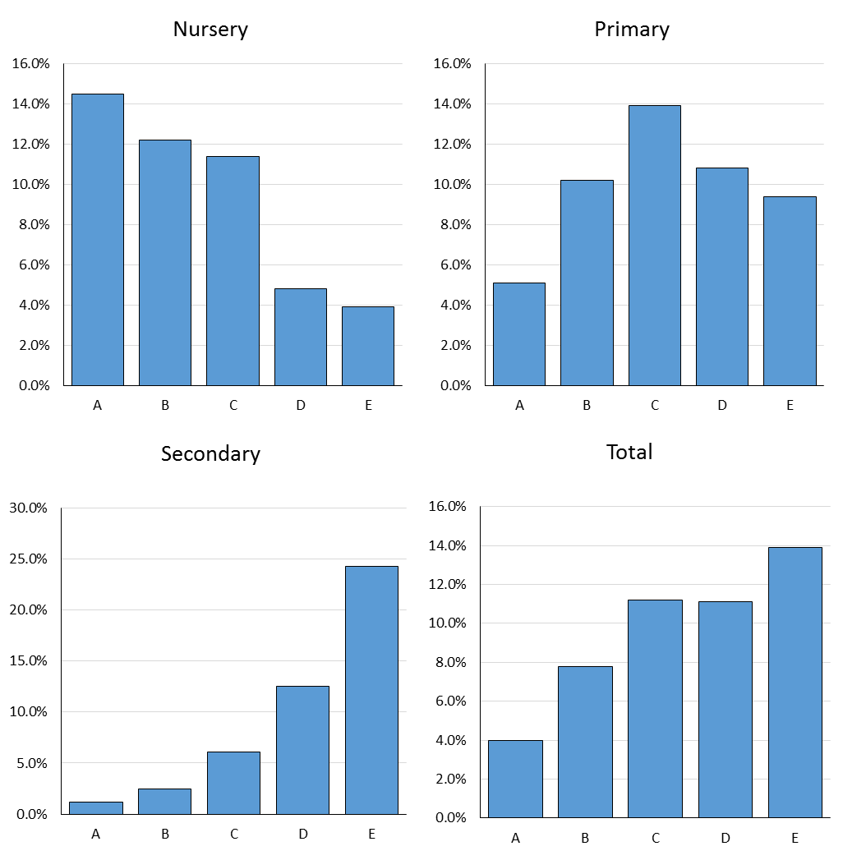

Moderation Outcomes and Identified Issues

Where issues were identified, some were common to all schools and phases and others pertinent only to particular key stages or phases. These are summarised and then described below:

- Reception and year 1 - difficulties in applying descriptors, nearly all of which refer to expectations above the age of the pupils.
- Key Stage 3 & 4 – data analysis suggested differing interpretations of the descriptors at stages D and E between schools.
- SEND - Identifying Special Educational Needs and Disabilities (SEND) in children with EAL and determining the extent to which EAL rather than the SEND is affecting progress in learning.
- Attainment - Discrepancies revealed by a comparison between stage of English and curricular reading and writing tests/assessment results.
- Assessment - A need to ensure all staff are familiar with best practice of assessing EAL using the DfE framework.

- Applying the descriptors from the DfE scale
The DfE National Proficiency in English Scale provides one set of general descriptors for assessing EAL, which are to be used for pupils from Reception to Year 11 and this has been supported in Lambeth with the provision of a more detailed grid listing criteria separately for reading, writing and speaking and listening.
However, within these, each descriptor has to be interpreted for the expectations in each year group and this appears to have caused issues for assessing children in the reception and early year 1 classes.
Most of the descriptors by stage C are beyond the age expectation for these younger children, for example,
‘May be able to follow more complex written English’.
‘Reads accurately but has difficulty interpreting complex texts related to the curriculum.’

‘Strives towards more developed pieces of writing for a range of purposes.’
It was evident that some schools are retaining all children at a stage A and B, based strictly on these criteria whereas in other schools, teachers are trying to find age-appropriate interpretations and moving children to a stage C or D.
Recommendations
It is hoped that a working party will be set up in the spring term 2018 to review the descriptors for use in reception classes and year 1 and produce a linked but more relevant set of criteria. This will support teachers in the assessments and also ensure more consistent use across schools and will be circulated to all schools in due course.
Meanwhile teachers should attempt to interpret the descriptors according to the objectives and expectations for the year group. Schools should be particularly wary of assigning a stage E to any young child with EAL. Although advice has always been to pay particular attention to the development of oracy in younger children when assessing EAL, if considering the higher stages of English, teachers should err on the side of caution and be aware that issues caused by the development of EAL often do not become apparent until a child is writing independently.
- Key Stage 3 and 4. Variation in interpretations of the descriptors at stages D and E
The data submitted to Lambeth suggests there are differences between school interpretations of the descriptors in stages D and E in Key Stage 3 & 4. It would appear that some schools are assessing pupils recorded previously as fully fluent (old Stage 4) at stage D, whilst most others have a high percentage at stage E.
Recommendations
Often at these advanced levels of English, EAL is only occasionally evident in specific elements of grammar in writing across the curriculum and reading comprehension that doesn’t match their technical fluency in reading. If occasionally present, this would place a child at stage D, rather than an E.
A child who is assigned a stage E, on the other hand, will be operating and achieving without any EAL support, at a level of competence equivalent to that of a pupil with similar ability, who uses English as his/her first language.

This is especially important to consider as the DfE states that there is no need to re-assess a pupil at stage E:

‘Once an EAL pupil has been assessed as fully proficient in English (where code ‘E’ – Fluent applies) it will not be necessary for the school to continue to re-assess the proficiency of the child on an ongoing basis.’

- Identifying SEND in children with EAL and determining the extent to which EAL rather than the SEND is affecting progress in learning

It has always been difficult to assess the stage of English proficiency in a pupil with EAL, who
also has a special need/disability and thus the extent to which EAL is affecting progress in learning. When a child has SEND, this also usually impacts on the rate of EAL development and in turn EAL will impact on the progress in learning.

Recommendations

The advice from the DfE in this context is as follows:

‘With regards to SEN children, the key will be the level of specific EAL support each child needs to engage with the curriculum / classroom learning. This will be distinct from any other SEN support needed to account for particular hearing or spoken difficulties and therefore the proficiency in English assessment should focus on the level of support which is specifically needed to account for the child being EAL. For example, the proficiency level descriptions cover expectations in terms of reading, writing and spoken language proficiency. For a child who is unable to communicate verbally due to their special educational needs, rather than their proficiency in English, then the elements of the description relevant to spoken proficiency will not be relevant. ‘

However, schools do not necessarily offer separate EAL and SEND support and good practice would be to ensure that any additional SEND support would be embedded in an effective EAL context using recognised EAL strategies. In these circumstances, when making an assessment of EAL, it is important to take greater account of other contextual factors for example:

- Length of child’s schooling in English
- Exposure to English and the model of English in the home
- How a child responds to the use of the first language in comparison to English
- Use of other means of communication by both adult and child, non-verbal, symbols and pictures

A separate framework has been produced in collaboration with teachers at special schools for their pupils, which take these factors into account. This can be used for children in mainstream schools with complex SEND and can be accessed on the Lambeth website as below:

https://www.lambeth.gov.uk/rsu/sites/www.lambeth.gov.uk.rsu/files/special_school_eal_stages.pdf
It should be noted that a child with SEND, should not be retained at a lower stage of English proficiency when the cause is their specific need/disability rather than EAL development.
- Discrepancies revealed by a comparison between Stage of English and curricular reading and writing tests/assessment results
Children developing EAL usually make rapid progress and by the time they become fluent speakers of English outperform English-only speakers in Lambeth schools. However, en route, they will not achieve age-related expectations whilst still at the early stages of learning English. An examination of the stage descriptors will demonstrate that a child at stage A, B or C cannot reach expected levels in reading and writing, as they require ongoing support. Even at stage C it is stated that,
‘Literacy will require ongoing support, particularly for understanding text and writing.’
‘Requires ongoing EAL support to access the curriculum fully.’
N.B. Children at an early stage of EAL may perform at a high level in maths, especially where translations have been used, or where the assessment was based on numeracy rather than a language-based aspect of maths.
During the moderation, there were instances where children had been assessed as a stage C English proficiency or even stage B and yet working at age-related levels. This was also reflected in an analysis made of all Lambeth primary schools – although a large percentage may represent a small number of pupils. (Table 1). It was more frequent with younger children, possibly as a result of the difficulties in applying the descriptors in this phase.
Table 1 Key Stage 1 & 2 Attainment by Stage of Proficiency in English 2017

Proficiency | Key Stage 1 |  |  | Key Stage 2
 | Reading | Writing | Maths | Reading | Writing | Maths
Stage A | 38% | 30% | 43% | 0% | 3% | 9%
Stage B | 62% | 56% | 64% | 24% | 20% | 46%
Stage C | 81% | 79% | 83% | 65% | 76% | 80%
Stage D | 90% | 86% | 88% | 77% | 85% | 83%
Stage E | 95% | 91% | 92% | 89% | 95% | 95%
English Only | 80% | 74% | 80% | 82% | 82% | 81%
Recommendations
For younger children, it is hoped that this will be addressed through the working party and the production of a revised set of descriptors for this age. However, when these discrepancies occurred later in KS1, 2, 3 and 4, it became clear during the moderation that there were issues within the assessments of either EAL or in some cases the curriculum.
It is strongly recommended that a comparison be made between a child’s EAL assessment and their reading and writing curriculum assessments to avoid these issues.
In addition, if a child is at a more advanced stage of English, but below expected levels in the curriculum, this can be indicative of SEND and will help pinpoint his/her needs more accurately. Similarly a comparison will help identify a child at an earlier stage of English, who is achieving well and may be amongst the most able children.

Assessment of EAL stages in the Early Years (Nursery)
Lambeth schools have been assessing stages of EAL fluency of children in the early years (nursery) for many years. Although the use of the DfE scale is not statutory in this phase, schools are now using the new Lambeth framework, which is linked to the DfE scale. Feedback suggests that teachers are finding this useful, but would like further exemplification of the descriptors embedded in the framework. One issue arising is that assessment at this young age relies almost totally on speaking, listening and understanding, so teachers can be reluctant to describe a child as at stage D or E, before the impact of EAL on writing becomes apparent.

Recommendations

Recorded observations have a tendency to report on what child has said rather than recording the child’s actual words. If there were a greater number of the latter, it would offer a deeper insight into a child’s understanding and also their English language development, which can then be built upon and extended. These talk snapshots need to be in a variety of active contexts to allow a child to develop and demonstrate the range of language. Talk around a photo of a completed activity will elicit a narrower range of language.
There should be added exemplification of criteria within the stages in the Lambeth Early Years Proficiency in English scale.
Grammatical issues typical of EAL development may not appear until a child is at an age where they are expected to be writing fluently. Teachers therefore, should be wary of assigning a stage E to a child in the Early Years phase. This is especially important as the DfE recommends that a child at this stage need never have their EAL development assessed again.
Good Practice and Advice for Effective Assessment
- Interpret the descriptors in relation to the expectations for the age group. Any comparisons should be made to a peer with English as a first language, of similar ability.

- Remember it is a best fit framework. It is not necessary to achieve all the criteria within a stage to assign that stage of English. The developmental pathway of EAL is not likely to be evenly distributed across the different aspects of language.

- Ensure that any assessment of writing is of work that is independent and has been unsupported and without scaffolding/rehearsal/editing. Look for an understanding of genre and cohesion as well as those grammatical issues known to be challenging for children with EAL.

- Consider the pupil’s use of English in all its aspects across the curriculum. A child may be writing reasonable fluently in Literacy/English, but not be able to communicate effectively in different academic areas such as Science.

- Build the EAL assessment into the school assessment cycle. The information is not only for the census but also to inform teaching and learning. Usually there is no need for additional work and observations, use that selected for curriculum assessment.
Be aware that the DfE states that – ‘for all proficiency levels below ‘Fluent’, it is expected that schools continue to monitor proficiency on an ongoing basis thereby ensuring that adequate levels of EAL support is provided to support the child’s education.
Re-assessment should take place prior to the spring school census, as data from an early autumn assessment skews analysis when compared to end of year curriculum tests/assessments. This is especially important when a child’s proficiency straddles two stages of English.
- A child with SEND should not be retained at a lower stage of English proficiency when the barrier to achievement and progress is their specific need/disability rather than EAL development.

- If, as is the case in many schools, there are a number of families who appear to use a language other than English, but who declare English as the only language in the home, it can be helpful to review school ethos and policies considering questions such as:

Is the recognition and value placed on the diversity of languages evident to parents/carers around the school?

How is the information about languages gathered? If an enrolment form is given to parents/carers to complete, rather than done with a member of staff who can explain the importance of first language development for children learning EAL, the information is less likely to be accurate.

- Ensure all staff are familiar with best practice of assessing EAL using the DfE framework. Class teachers and teaching assistants should be encouraged to use the information gathered to plan for progression in EAL.

- It is advisable that the data, once inputted by office staff but before submission to Lambeth, should be checked by the person responsible for EAL to avoid any anomalies. Ensure that every pupil who has a language other than English recorded also has a stage of English assigned. Check for a logical pattern of allocated stages – one school was noted to have no children at stage C – and investigate if unexpected.
Conclusions
Finally, the scope and limits of the DfE Proficiency in English scale have been recognised and were indeed observed during the moderation process. Its descriptors are not only general and sparse but have the impossible task of applying to children across their whole school career.
Providing a brief snapshot, the DfE states that it merely attempts ‘to distinguish between pupils who lack a basic command of the English language versus those who are bilingual and have mastered English sufficiently to access the curriculum.’
Children with EAL are not a homogeneous group, they have different backgrounds and needs and their development of EAL is not along a straight pathway. A phase-related scale which provides more detailed criteria for understanding, speaking, listening, reading and writing across the curriculum and which reflects the known challenges in these areas for children with EAL would proffer valuable information to teachers when planning, teaching and assessing. A variety of scales linked to the DfE Proficiency Scale have been produced by local authorities and organisations, varying in comprehensiveness and workability in the classroom, offering a more thorough assessment and identifying areas for development. However, should schools choose to use one of these alternative frameworks, it should be remembered that ultimately the DfE Proficiency in English scale has to be used for the data entered into the school census.
In conclusion, feedback suggests that the moderation process was helpful to both schools, where staff had opportunities for discussion around their children and more generally EAL and for the Lambeth team who have a better picture of the consistency, strengths and challenges in the assessment of EAL in Lambeth schools using the DfE Proficiency in English scale. This will enhance the data analysis and reports provided by Education Research and Statistics for schools and hopefully contribute to the further development of the assessment materials, which will be circulated to schools later in the school year.

