
07 December 2022
Our ref: IRN14268643

Dear ‎Sir / Madam

Environmental Information Regulations 2004 – Utilities parking suspensions Narbonne Avenue

This request is being handled under the Environmental Information Regulations 2004.

Your request
Can I please have the following;

- a list of all the 'utilities' parking suspensions arranged between 89 and 137 Narbonne Avenue, SW4 in 2022

- who in Thames Water is booking these works

- who in Lambeth is arranging the parking suspensions for these works

- how much Thames Water are paying Lambeth for these suspensions

- what work is supposed to have been happening on these suspensions

- why no work has been carried out on the, to date, 4 weeks of parking suspensions for this area

Our response
- a list of all the 'utilities' parking suspensions arranged between 89 and 137 Narbonne Avenue, SW4 in 2022
Please see chart below
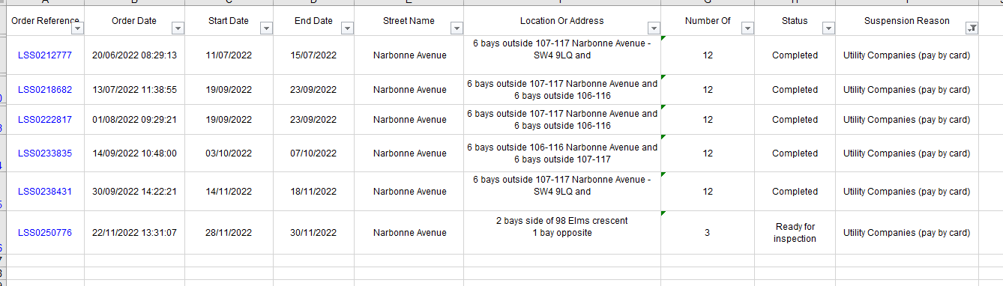
- who in Thames Water is booking these works
I can confirm that we have reviewed this part of your request we consider disclosure would breach the Data Protection Act 2018 and therefore engage Regulation 13: Personal Data to this request.

We consider disclosure would breach the Data Protection Act 2018 and therefore engage Regulation 13 to this request.

The definition of personal data is set out in provision 3 of the Data Protection Act 2018 as follows:-

(2)“Personal data” means any information relating to an identified or identifiable living individual

(3)“Identifiable living individual” means a living individual who can be identified, directly or indirectly, in particular by reference to—

(a)an identifier such as a name, an identification number, location data or an online identifier, or

(b)one or more factors specific to the physical, physiological, genetic, mental, economic, cultural or social identity of the individual.

We note this request asks for information which would allow an individual(s) to be identified.

I have considered whether it would be fair to disclose the information including whether disclosure would cause any unnecessary or unjustified damage or distress to the individual concerned; the individual’s reasonable expectations of what would happen to their information; and balancing the rights and freedoms of the data subject with legitimate interests.

In this case, I can confirm that it would not be fair to the individuals to disclose their name(s) as it could cause distress to the individual(s).

I do not consider that the individuals would expect the Council to disclose any information which may allow them to be identified. Although I acknowledge the legitimate interest in disclosing general information relating to these utility works, I do not consider the legitimate interest overrides the rights and freedoms of the individual on this occasion.

This letter represents a Refusal Notice for this part of the request.

- who in Lambeth is arranging the parking suspensions for these works

Customers book suspensions directly through our online system
- how much Thames Water are paying Lambeth for these suspensions
Full details of suspension costs can be seen below
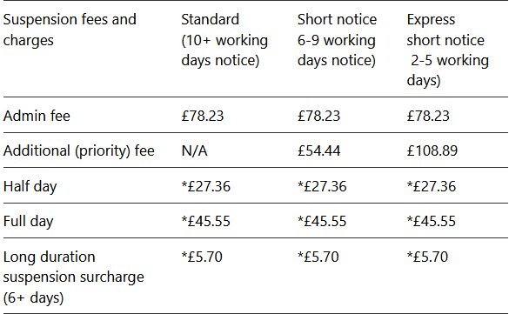
- what work is supposed to have been happening on these suspensions
Utility work
- why no work has been carried out on the, to date, 4 weeks of parking suspensions for this area
I can confirm that Lambeth Council does not hold the information requested. Regulation 12(4)(a) of the EIR states that a public authority may refuse to disclose information to the extent that it does not hold that information when an applicant’s request is received.

You may contact Thames Water to request this information and they may be able to provide the information requested.
Right to Review
If you are dissatisfied with the way in which your information request has been dealt with you can request an internal review. Tell us why you are unhappy with our response within 40 working days, and it will be looked at afresh. We will aim to provide you with our review response within 20 working days.
By email: foi@lambeth.gov.uk (Please quote the reference number above) or by writing to:
London Borough of Lambeth
Freedom of Information
P.O. Box 734
Winchester
S023 5DG

Right to Review
If you remain dissatisfied with the outcome of the review you have a further right to appeal to the Information Commissioner, who regulates the implementation of the Freedom of Information Act. The Commissioner can be contacted at the following address:
The Information Commissioner's Office
Wycliffe House
Water Lane
Wilmslow
Cheshire SK9 5AF.
Telephone: 0330 123 1113
Website: www.ico.org.uk
I will now close your request as of this date.

Yours faithfully
‎FOI Team
London Borough of Lambeth

Website: www.lambeth.gov.uk

Lambeth - a Co-operative Council
‏

