To Lambeth SAG Request for Use of Space near Westminster Bridge for Devizes to Westminster Canoe Race, 9 & 10 April 2023
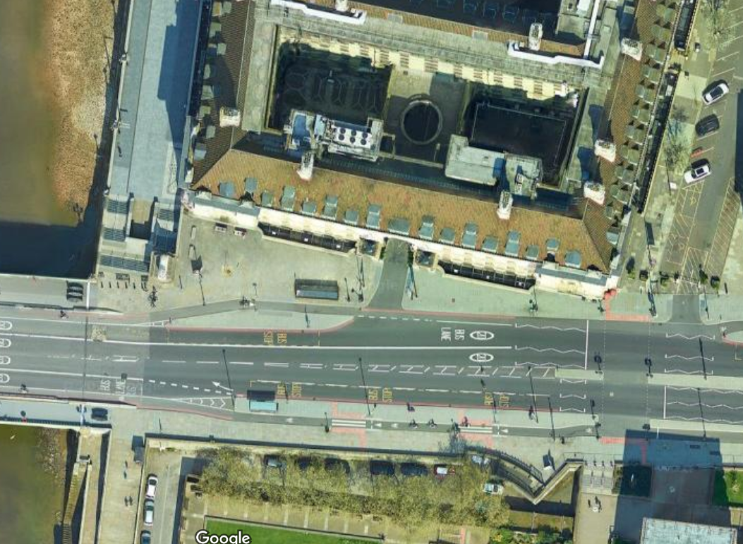
Permission requested for use of marked space for Devizes to Westminster Canoe Race on 9 & 10 April 2023.
To be used for
1) First Aid
2) Self-contained anti-vandal toilet unit.
The area indicated is now demarcated by new ~1.2m high steel bollards. It is out of the main thoroughfare.

