HRA Fire Safety Strategy
September 2020

Next Revision Date: January 2024

Foreword
Local authorities have a number of responsibilities relating to Health and Safety. This HRA Fire Strategy solely covers those relating to those as a landlord to properties within the Housing Revenue Account. This consists of homes for over 33,000 council tenants and leaseholders and 200 council owned hostels which are used as temporary accommodation.
Above all else, the most important duty of any landlord has to be ensuring the safety of their tenants. An effective approach to fire safety is also required to make sure we protect people’s homes, protect the environment, that we can continue delivering services and that we have an appropriate response to emergency incidents.

Setting the framework
Lambeth operates under a Quality Management System based on relevant ISO standards and PAS 7 (the management system standard for fire safety). A diagram showing how different elements of the fire safety framework interrelate is shown in Appendix 1.

The 5 themes

Ensure Resident Safety
The council carries out the requirements of the Regulatory Reform (Fire Safety) Order 2005 and ensures that Fire Risk Assessments (FRAs) are carried out. These form the basis of our approach to ensuring residents are kept safe.
A Risk Matrix Approach which considers factors such as the height, construction and access of buildings determines the frequency of assessments, and allocation of capital resources to our fire safety investment programme. This includes guiding decisions on the installation of sprinkler systems, fire doors, fire alarms and the approach towards external wall insulation.
Part of ensuring resident safety is having arrangements in place in the event of an emergency. We are developing a clearly structured approach to evacuate residents if necessary and making sure there is capacity to address the consequences of any emergencies within reasonable time scales. The Council already has robust corporate response arrangements around supporting the Emergency Services in the event of an incident and ensuring the welfare of the resident and people affected by such an emergency is the paramount concern.

Engage residents
Fire safety is a joint responsibility, residents need to ensure that communal areas are kept clear, and that sensible precautions are taken within the home to prevent accidental fires. The council takes a robust approach in raising awareness of resident responsibilities and taking necessary enforcement action.
Lambeth has introduced a new approach to resident involvement and options for how services can be scrutinised. This ties in with the direction of travel proposed by the Hackitt Review and the emerging Fire and Building safety Bills – transparency of information, how information is shared and resident rights and responsibilities. Residents should be involved and consulted upon the decision-making process for works which impact on resident safety and there should be an effective mechanism for residents to raise safety concerns.
The current approach is to have a quarterly meeting with residents, the Fire Safety Forum. This has been acting as a sounding board to keep residents in the loop with what is going on and obtain informal feedback and allow us to understand their concerns.

Lambeth is about to update its Resident Involvement Compact (delayed by C-19), which will include how best to engage residents in the safety of their homes, in line with current and emerging guidance.
Lambeth aim is that residents have useful and meaningful involvement both at a strategic level and the ability to influence specific projects taking place within their homes and buildings.

Keeping up to date / Working in Partnership
Following the tragic events at Grenfell regulations and government policy relating to residential fire safety is in a state of flux. The Hackitt Review (2018), “Building a Safer
Future, Independent Review of Building Regulations and Fire Safety” has made over 50 regulations. Many of these will require new government regulations. Following on from this we are also keeping abreast of the emerging Fire and Building Safety Bills as they go through parliament.
Through the regular updating of this strategy we will make sure that the council fulfils its obligations and adopts relevant best practise. This is a live document with the associated action plan and dashboard that is considered on a regular basis by the Housing Health and Safety Board. The Health and Safety Board includes representation from the London Fire Brigade with whom we work very closely.
Lambeth is also an active participant in London Council’s Fire Safety meetings, and events organised via the GLA and similar bodies. The way that fire safety is delivered in Lambeth in a join-up way can be summarised in the diagram below:

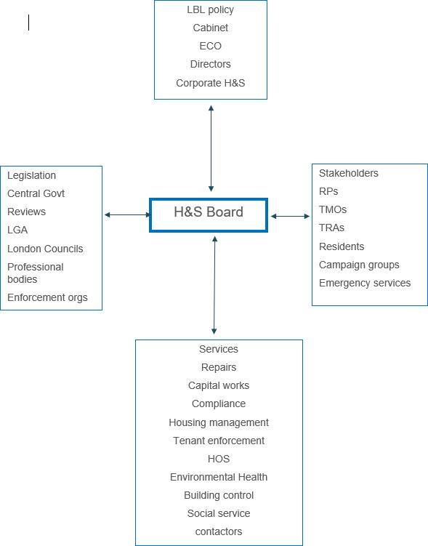

Figure 1 - Partnership Approach to Fire Safety in Lambeth

Innovate and Improve Services
Lambeth wants to be at the leading edge of new approaches and seen an innovator that other London boroughs look to as an example of best practise. In particular there are technological opportunities to improve both the quality and efficiency of Lambeth’s approach to fire safety we wish to develop.

Our next tasks for Fire risk and Capital for 2020/21 are;

- To develop a geographically based asset management plan / strategy specifically around building and fire safety and compliance, the plan will list out in order of priority what actions are required and when that work is programmed to be undertaken, picking up fire risk work more proactively than waiting on the FRAs.

- Start to develop the management recommendations, therefore we need to decide who will manage the holistic safety approach to each block and who will be responsible for managing the safety of multiple blocks and who has overall responsibility. (Building Safety Managers).

Looking after vulnerable residents

In recognition of the additional risk fire present for residents of sheltered housing and in council owned hostels used at temporary accommodation specific and more detailed risk assessments are applied to this type of accommodation.
Vulnerable tenants, regardless of their housing situation, are eligible for fire safety checks and smoke alarm installation provided free of charge by the London Fire Brigade. Where appropriate, vulnerable tenants should be assisted in making use of these features.
A pan-London data capture exercise, conducted across a number of years, has highlighted which residents are most at risk of fire.¹ All recent fatalities in the Borough of Lambeth involved individuals who would have been considered vulnerable in this context as they met at least three of the following criteria;
- Sole residents
- Disabled (physical, or self-declared mental health issue or learning difficulty)
- Social housing
- Over 60 years of age
- Single parents (child under 15)
- Smokers

In the longer term Lambeth wants to be able to identify all those at increased risk, including hoarders, and ensure that appropriate prevention measures are put in place, working in conjunction with the fire service.

Building Safety Bill

The Building Safety Bill, BSB have all our Building safety cases logged with the regulator by April 2023 with a go live in October 2023
Have developed a high-rise matrix – with all the info we have on each of the blocks - now working with Savills on a joint approach using data from FRAs and survey work to ascertain the structural integrity of a block in the event of a fire.

The plan is to use the FRA information and the data from the structural integrity to start building the building safety cases for all 127 blocks, including all TMO blocks over 18m
Joint approach to Building Safety Bill, there will be a joint strategy with private sector and Building control, that will include the whole of the LBL stock, that will also be accessible to the department of levelling up in October 2023.

¹ https://data.london.gov.uk/dataset/london-fire-brigade-incident-records

Appendix 1 Quality Management System Framework
