Fire Safety on Balconies Guidance

Review Date: April 2025

Introduction

  - Following a number of fires that have occurred on balconies within the London area, the London Fire Brigade (LFB) have carried out a review of fires involving balconies. This document summaries some of the findings to illustrate some of the risks. Officers should use this document to understand the risks of not managing and enforcing the rules of private balcony use.
  - This information should be used to inform fire risk assessments. It will assist officers who are responsible of the management of buildings and tenancies to assess the risk of fires involving balconies and actions they should take.

Balcony Fires

  - Over recent years the LFB Fire Investigation Team has attended a large number of incidents where fires have occurred on balconies. The cause of the majority of those fires has been due to the unsafe disposal of cigarettes by the resident themselves or their neighbour above. Another significant number of balcony fires have been caused by residents using them for barbeques. Some barbeques are sold branded specifically for use on balconies. A balcony is never a safe place to have a barbeque.
  - The likelihood and impact of a fire occurring is greatly increased if items are stored on balconies. Residents sometimes use balconies to store items of furniture or electrical appliances. If a fire was to occur then this can contribute to fuel an existing fire and, in some cases, be the cause of the fire’s ignition.

LFB Case Study 1
A fire occurred on the balcony of a flat on the 13th floor of a 14 floor purpose built block of flats,built in 2015.
The fire occurred as a result of unsafe disposal of a cigarette into a planter that contained drypeat. There was no fire spread into the flat.

LFB Case Study 2
A fire occurred on the 4th floor of a six floor purpose built flat in the balcony area. The fire was contained to the flat of origin and was believed to have been caused accidentally bycandles/tea lights being to close to combustible articles. The whole of the balcony was damaged and the lounge had approximately 80% damage due to the spread of fire, heat and smoke. The smoke also travelled throughout the flat leading to further damage. The fire was able to spread from the balcony to the adjacent dwelling / flat via an open window.
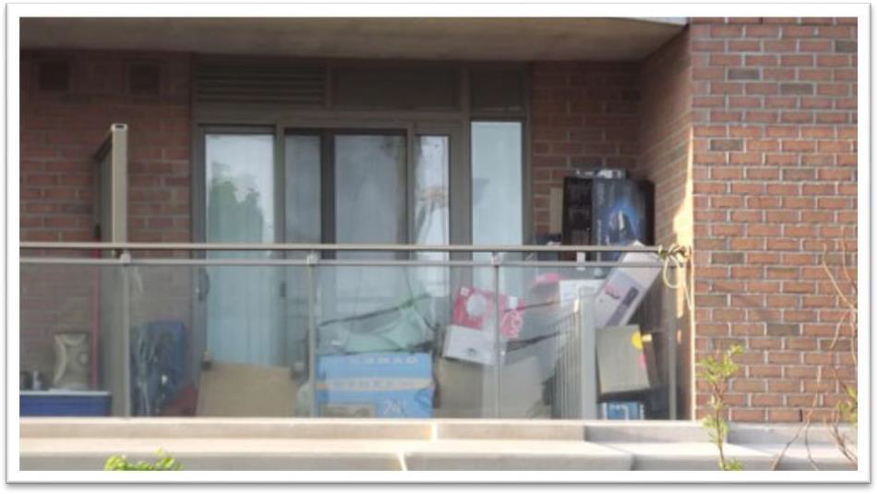

Figure 1 - Storage on a Balcony which should be avoided

Taking steps to prevent balcony fires

  - Fire Risk Assessments (FRAs) are carried out on each block. These will identify any fire risks associated with balconies. The FRA team work with and advise housing officers of steps to be taken. Residents should be advised to keep storage on balconies to a minimum, in order to reduce any potential fuel load which could accelerate a fire. The storage and use of white goods on balconies is prohibited as they can contribute to excessive fire-loading and are potential ignition sources.
  - Housing Officers should check residents' balconies as part of their inspections and advise the tenant if they see that a balcony is being used as storage. A follow up inspection should be conducted after the resident has had sufficient time to remove goods from the balcony.
  - If an Officer suspects that the resident may be suffering from a hoarding disorder, then they should also follow the process outlined in the Hoarding Procedure
  - The use of BBQs or patio heaters on or directly underneath balconies is expressly prohibited in the Lambeth tenancy agreements. All Lambeth staff associated with the management of the block, including Housing Officers, should encourage the responsible use of balconies and report any misuse.
  - We cannot ban tenants and leaseholders from smoking on their balconies.
  - It is the council’s responsibility as the building owner to inform residents of the fire risks associated with balconies, including around safe cigarette disposal. Residents should be encouraged to contact the housing office if they have any safety concerns. This information should be provided in response to any specific concerns and included more generally in wider communications with residents about fire safety.
  - The Lambeth Fire Safety Team (HMfiresafety@lambeth.gov.uk) should be contacted if any further guidance is required on specific cases.

