|  |
| --- |
| 2015/16 Cumulative  Equality Impact Assessment |

Date to Corporate EIA panel: 4 February 2015

Date to Cabinet: 9 February 2015

Date to Full Council: 25 February 2015

Introduction

At the heart of our ethos in Lambeth is the principle of ambition and fairness for all. This has never been more important than at a time when our financial resources are being eroded by central government, and we are committed to maintaining it in delivering the services that our residents rely on.

Lambeth is proud to be home to over 300,000 people, all of whom have needs and aspirations, and at every stage of policy development and delivery we consider how the decisions we make will affect them. We have taken great care in putting this cumulative impact assessment together, and as get we get new information and our policies develop we will refine this further.

We are facing huge financial challenges and some of the decisions we are making have been difficult. All have been made with the interests of our residents at heart, and the work that we have done to strengthen communities and understand the needs of our residents will help us to support them in the years to come.

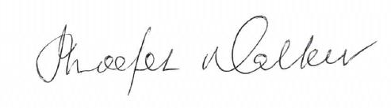

Councillor Imogen Walker

Deputy Leader and Cabinet member for equalities

1. Our approach to equality impact assessing our 2015/2016-2017/18 budget

**Scope of this assessment**

This assessment identifies those areas within the 2015/16-2017/18 budget which are relevant to equalities and seeks to describe their potential equalities impact when taken together. Our approach for assessing the equalities impact of savings proposals is an ongoing process which underpins cooperative commissioning. At this stage the analysis is indicative and as individual proposals are further developed and implemented they will be subject to further assessment.

**Our legal duties**

Prior to April 2011 public authorities, like Lambeth Council were under a legal duty to have due regard to the need to eliminate discrimination and promote equality with regard to race, disability and gender, including gender reassignment, as well as to promote good race relations. In April 2011 the Equality Act (2010) introduced a new public sector duty which extends the protected characteristics covered by the public sector equality duty to include age, sexual orientation, pregnancy and maternity, and religion or belief.

Section 149 Equality Act 2010 requires public bodies to have ***due regard*** to the need to:

* **eliminate unlawful discrimination**, harassment, victimisation and any other conduct prohibited by the Act;
* **advance equality of opportunity** between people who share a protected characteristic and people who do not share it; and
* **foster good relations** between people who share a protected characteristic and people who do not share it.

Having ***due regard*** means consciously thinking about the three aims of the Equality Duty as part of the process of decision-making. This means that decision makers must be able to evidence that they have taken into account any impact of the proposals under consideration on people who share the protected characteristics before decisions are taken – this includes decisions relating to how they act as employers; how they develop, evaluate and review policy; how they design, deliver and evaluate services, and how they commission and procure from others.

In the context of major reductions being required we have therefore endeavoured to ensure that:

* The process followed to assess the equality impact of financial proposals is robust; and
* The impact financial proposals could have on equality groups is thoroughly considered before any decisions are taken.

By law as assessment must:

* Contain sufficient information to enable a public authority to show it has paid “due regard” to the equalities duties in its decision-making; and
* Identify methods for mitigating or avoiding any adverse impact

Our approach to ensuring equality impacts are considered as part of cooperative commissioning and financial decision making is therefore designed to demonstrate that the Council has proper regard to these aims, in accordance with its statutory equality duties. It seeks to ensure that even in this time of economic challenges the substantial savings are identified and delivered in a balanced and sustainable way. This is key to the political administration who have prioritised equality as one of the three key elements of their vision for the borough (equalities- protecting those that need it most; resilience – growing strong communities; and early intervention and prevention- stopping problems from happening in the first place).

### Our Approach

In 2010 Lambeth council started its journey to becoming a Cooperative Council. This means that we believe that *working together* to empower people we can achieve more than if the council acts alone – we call this coproduction.

The council is focused on achieving 13 outcomes for local communities. These have been identified through evidence and coproduction with local people and are organised under three themes: cleaner streets; more jobs and safer communities (see below for a visual summary of how the 13 outcomes fit together and our overarching strategy around resilience, prevention and equality).

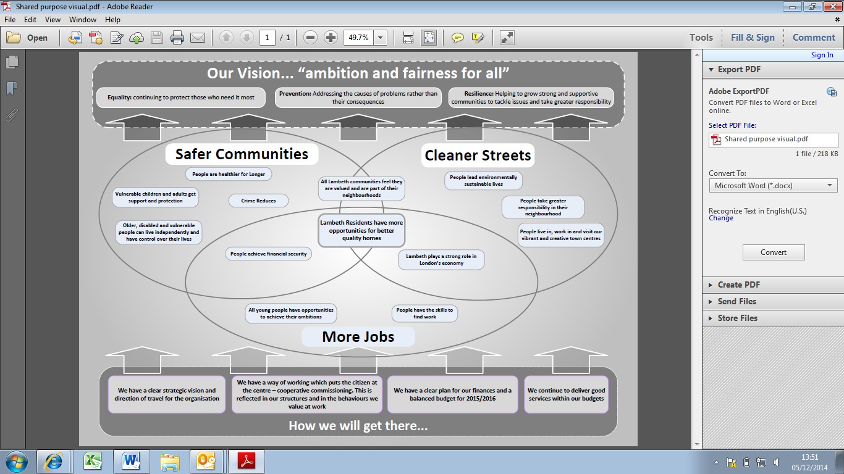

In 2014/15 we introduced three outcome panels. They bring together officers and politicians to shape the cooperative commissioning cycle and work out how best to spend the budget available to achieve outcomes for our communities. The three outcome panels – Housing Jobs and Investment; Community Wellbeing and Neighbourhoods, Environment and Sustainability developed the proposals which underpin the 2015/16-2017/18 budget. Each outcome panel has considered the equalities issues associated with the proposals as part of the discursive development of proposals.

For the first time each new proposal includes an equalities relevance assessment. Where possible, equality analysis sets out the equality implications, justification and mitigations. We believe that bringing the equality analysis into each individual budget proposals demonstrates how we are mainstreaming equalities and making it part of everything we do.

In undertaking the cumulative impact assessment we have focused on the following:

* As the proposals have developed they have been screened for potential impacts on those with protected characteristics (race, sex, disability, religion or belief, sexual orientation, pregnancy and maternity, and age), and on non-statutory equalities considerations that Lambeth includes in its equalities analysis: language, socio-economic and health and social wellbeing. For the first time we have not completed separate EIAs on each proposal, we have embedded our equality analysis as part of each individual proposal (see Appendix 2 Budget report, December 2014).
* Initial assessment of the potential cumulative equalities impacts has been carried out, and is reported here along with the potential impact of the budget proposals on the community outcomes and equality objectives.
* This cumulative EIA report will be considered by Corporate EIA panel and then by Cabinet alongside the budget, and also by Council.

2. Evidencing what matters most to local people

**Perceptions of the council**

Despite the budget reductions over the last few years, satisfaction with the council (64%) and the proportion of adults feeling that the council provides value for money (48%) has reached the highest levels recorded (2014 residents’ survey). Residents are more satisfied with their local area as a place to live than ever before (88%) and they are feeling more informed about the council (64%). This is extremely positive given the scale of the cuts already implemented and demonstrates the impact the council is having.

**Figure 1:**



However, it is important to note that a significant number of local residents do not understand that the council is faced with reducing budgets and so expectations of council services are likely to remain high (45% of residents think the council has a reduced budget, 31% think the council has more or the same amount of money and 24% don’t know, April 2013, see figure 2).

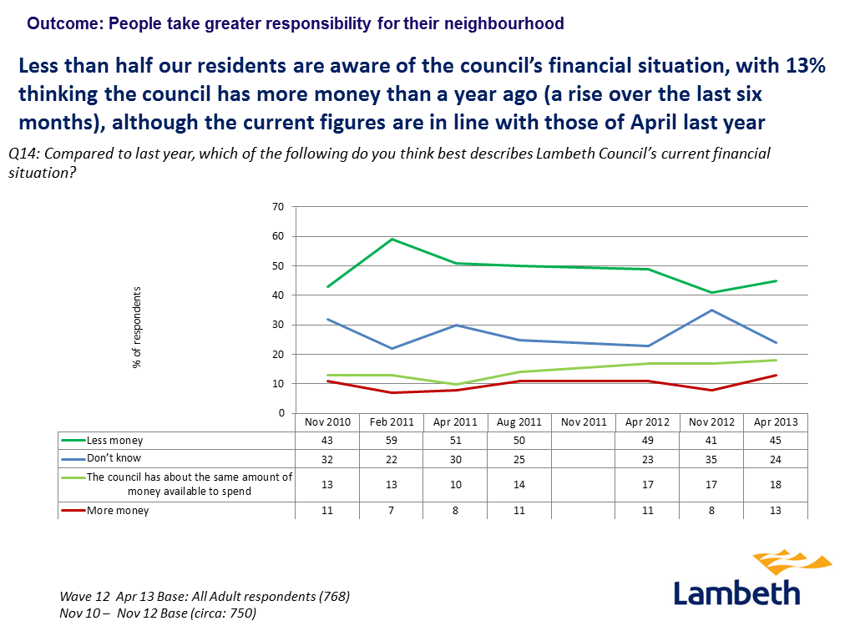**Figure 2**:

**Which outcomes matter most?**

This year, instead of asking about satisfaction with services, we asked residents to prioritise the council’s outcomes. Figure 2 overleaf shows that when asked on the doorstep the outcomes that people say matter most are around safety (54%), cleanliness (44%), housing (41%) and young people (41%).

Of those who prioritise safety - tackling gangs and violence (88%), dealing with anti-social behaviour (87%), ensuring there are safe places to play (82%) and supporting victims of domestic violence (72%) are seen as most important. People who prioritise cleanliness think that street cleaning (84%), waste reduction and recycling (67%) and road and pavement repair (65%) are most important.

However, we also conducted more in depth qualitative research to really get people to think about the outcomes. This research found a different prioritisation with crime still placing at the top, but other outcomes including ‘vulnerable adults and children get support and protection’ and ‘people having the skills to find work’ moving into the top 3.

This evidence suggests that when given an opportunity to consider the outcomes in more detail that local people prioritise those areas that impact on the most vulnerable.

**Figure 2:**



**Figure 3:**



**Potential changes to services**

We previously asked residents about the services they think need to be protected and those which could be reduced. Residents prioritised **all social services, support services for disabled residents, weekly waste collection, youth and children’s centres**. On the back of these findings many of these services have previously been protected. Areas where residents would be most comfortable for the council to introduce or increase fees or fines are fly-tipping and graffiti removal, arts and cultural activities, evening classes/adult education, sports and leisure facilities, parking and bulky waste collection. It is worth noting that 21% of residents did not think that fees or fines should be introduced or increased for any services.[1]

Different residents, because of their circumstances and the types of service they use, have different priorities and concerns. Detail on which equality groups are more concerned than average about particular issues is as follows:

* **Ethnicity:** It is important to note that the different ethnic groups in Lambeth have very different socio-economic profiles and so some apparent differences by ethnicity may actually reflect the work profile, tenure or deprivation experienced by a particular group, rather than their ethnicity.White British residents are more likely to prioritise he council’s outcomes around safety and cleanliness and protecting the vulnerable. White residents from non-British backgrounds are more likely to say that the level of crime is the thing that most needs improving in their local area.   
    
  Black Caribbean residents, who on average have been in residence longer than other groups, have consistently rated services and the council less positively since we started collecting comprehensive perceptions data 15 years ago. Black Caribbean residents are more likely to be dissatisfied with the value for money provided by the council, more likely to be dissatisfied with the way the Council runs things. They are more likely to say that the Council should prioritise spending on better quality homes and on the Lambeth economy and employment.

Black African, Asian and Mixed raceresidents’ priorities for council spending are in line with the borough average, with the exception of healthy lives and supporting vulnerable people which black African residents rank less highly than average.

* **Age:** Young people (age 18 – 24) are less likely to agree that changes to the local neighbourhood benefit them personally and they are less likely to know how to get involved with what the Council is doing locally. They are more likely to think helping young people achieve their ambitions is important. Older residents(65+) are more likely to think the council should prioritise spending on vulnerable people and helping residents live healthy lives.
* **Gender:** Crime continues to be the main concern for both men and women. Women are more likely to say that the council should prioritise spending on helping young people achieve their ambitions. This likely reflects that they are more likely to have caring responsibilities for children and young people than men. Men are more likely to say helping people lead healthy lives should be a priority for council spending, the latter possibly reflecting that male residents are more likely to say they their health is good than women.
* **Sexual orientation:** Local data[2] shows thatLesbian, Gay or Bisexual residents are more concerned about pollution and homelessness, however drawing on national data[3] we know that LGBT people experience problems finding accommodation where they feel safe and that is LGBT-friendly. They also perceive a reduction in sexual health and mental health services that addresses their specific needs, which has created greater feelings of marginalisation and invisibility as specialist LGB services and support are removed; we can reasonably expect attitudes to be similar in Lambeth. Heterosexual residents are more concerned about a lack of jobs.
* **Religion/belief:** Christian residents are more likely to say that job prospects are the most important thing in making Lambeth a good place to live. They are more likely to say that encouraging businesses to bring jobs to the borough and providing advice for small businesses and career advice and mentoring for Lambeth residents is very important. They are more likely to say that standards of council and private rented housing in the area should be improved and that shopping facilities should also be improved.
* **Disability:** Residents with a disability or long-term illness are more likely to think the council should prioritise spending on vulnerable people
* **Socio-economic:** Residents living in the least expensive quintile of housing, an indicator of socio-economic deprivation, are more likely to prioritise outcomes relating to housing and jobs.
* **Carers** are more likely to say that the Council should prioritise spending on supporting vulnerable people in the community and helping young people to achieve their ambitions.

3. Equalities relevance of individual budget proposals

**Methodology**

The proposals analysed in this report cover the full range of savings proposals contained within the 2015/16-2017/18 budget. The analysis in this report is subject to change in response to alterations to any of the individual proposals. The table below summarises the relevance to equality of each proposal, and described the equalities groups which the proposals may have a disproportionate impact on when compared with the Lambeth population as a whole.

It is worth noting that the customer profile for some services does not reflect the borough-wide population. For example, support services to older people are more likely to be used by older people. This means that any change to activities will have a disproportionate impact by age when compared to the borough population overall, but it may be a proportionate impact on service users (i.e. the profile of customers before and after the change is likely to be the same).

Proposals previously agreed which will be implemented from 2015/16 onward have already been subject to equality analysis and amount to £37.6m. Therefore, only new proposals were assessed for relevance to equalities. This relevance assessment is summarised in the table below. The majority of proposals which were assessed as not relevant to equalities relate to changing how services and activities are funded, as opposed to changes to the services themselves.

It is also important to note that there are proposed £12.7m in new savings to be realised through council tax adjustments. £6.9m of this reflects that the number of properties from which we are collecting council tax has increased, and that we are getting better at collecting council tax; while £5.7m will be achieved through increasing council tax rates by 1.99%. The council tax increase will have some equality implications and a full EIA is in the process of being drafted. Prior to the formal decision being taken to increase council tax the Corporate EIA panel will consider the equality analysis and mitigations which the organisation intends to put in place.

All proposals which are relevant to equalities have been discussed at the Corporate EIA panel and those discussions have been built upon through Overview and Scrutiny.

The recommendations of Overview and Scrutiny which relate to equalities are:

1. that there continue to be discussions to strengthen the equalities framework reflecting the committee’s concern that conversations with service users, carers and people with protected characteristics do not always happen at pertinent times
2. that specifically in relation to the proposals for adult social care and health integration there be robust monitoring of implementation and evaluation of impacts on communities and a report back on impacts be brought to Overview and Scrutiny Committee for review

**The Corporate EIA panel will have consideration to the recommendations of Overview and Scrutiny and 1. check that conversations with service users, carers and people with protected characteristics are meaningful and happening early in the process in relation to the 4 proposals highlighted in this assessment (children’s, adults, street lighting and community safeguarding); and 2. Schedule conversations following implementation of the proposals to understand what the impacts on communities may have been.**

**Figure 5**

|  |  |  |  |
| --- | --- | --- | --- |
| Proposal | Equalities Relevance | Date discussed at Corporate EIA panel | New Savings |
| **Neighbourhood Environment and Sustainability** | | | |
| Capitalisation of revenue funded assets | Not relevant to equalities |  | 920 |
| Reduced subsidy for bulk recycling containers | Relevant to equalities (socio-economic, ethnicity) | Dec 2014 | 600 |
| Increased income for pest control | Not relevant to equalities |  | 30 |
| Capital investment in LED and control management | Relevant to equalities (disability, age, pregnancy/maternity) | Dec 2014 | 600 |
| Community safeguarding | Relevant to equalities  (ethnicity, socio-economic, gender) | Dec 2014 | 252 |
| Re-procuring of parking contracts | Not relevant to equalities |  | 500 |
| **Housing Jobs and Investment** | | | |
| Savings to business growth and regeneration | Not relevant to equalities |  | 185 |
| Fees, charges and traded services | Not relevant to equalities |  | 125 |
| Social welfare advice HRA recharge | Not relevant to equalities |  | 240 |
| Housing benefit admin costs grant funded | Not relevant to equalities |  | 120 |
| **Community wellbeing** | | | |
| Children’s services | Relevant to equalities (age, gender, disability, socio-economic, health) | Dec 2014 | No new savings but revisions to how previously agreed savings will be achieved |
| Adults’ services | Relevant to equalities (age, gender, disability, socio-economic, health) | Jan 2015 | 20,000 |
| Total new savings |  |  | £23.572m |

The rest of this section provides a narrative summary of the totality of new proposals being brought forward through the 2015/16-2017/18 budget.

**NEIGHBOURHOODS, ENVIRONMENT AND SUSTAINABILITY**

Waste Strategy:

* As part of our waste and cleansing contract with Veolia, we currently pay an annual sum to cover depreciation in the value of vehicles, buildings and equipment.  By paying this charge through capital funding, rather than using revenue (as we currently do), we can save the service nearly **£1m per year**.
* Save **£600k per year** by charging an annual hire charge for recycling bins for blocks of flats, which are currently 100% subsidised by the council.  We will still subsidise the cost by 25% to keep the incentive for recycling and any charge will not affect those in social housing, where reduction in costs elsewhere means this cost can be met without an increase in rents.
* Make an extra **£30k per year** by promoting our already successful pest-control, animal welfare and environmental health service to increase its work and issue fixed penalty notices to tackle graffiti, fly-tipping and public health issues.

Street Lighting:

* Save **£600k per year** by switching to less energy intensive and easily maintained LED street lights. Investing in LED technology and implementing a Control Management System which will enable the council to control street lighting down to an individual street lamps. This will require an up-front capital investment, but the LED technology is much cheaper and more environmentally friendly – so there will be positive environmental impacts as a result of this proposal. Following the move to LED lights with a centralised control, the council will develop a set of proposals that meet the approved British Lighting Standards to maximise the benefits of adaptive lighting.

Parking:

* All separate contracts relating to parking (e.g. issuing permits, penalty charge notices, maintenance of machines, online and phone payment services) will expire in July 2015 and will be re-procured under one single contact. We aim to get a 7% discount by using one large contract, which should save **£500k per year**.

Community Safeguarding:

* Save **£952k over the next three years** by bringing all crime and anti-social behaviour issues under one ‘Community Safeguarding’ service which will be organised through geographical neighbourhood teams, working closely with residents to make reporting easier and prevention work more effective.
* The only borough-wide functions will be either grant funded or paid for through specific programmes such as Violence Against Women and Girls programme.
* Income will be raised through the sale of CCTV provision to registered social landlords and other housing providers and increases in certain licensing fees for businesses.

**HOUSING, JOBS AND INVESTMENT**

Business Growth and Regeneration:

* This is an area of council work that’s funded through the planning system and significant savings have already been agreed, with a total of **£820k over the next three years**. There will be no significant changes to the service and no direct impact on residents.

Private Sector Housing:

* Lambeth council is required by law to provide an environment health service to investigate, licence and enforce housing rules in the private sector. We are not allowed to make a profit from this work but we can change the way we charge for services. To save **£125k over three years**, we will move from a fixed fee for landlords to hourly charges, be tougher with enforcements and encourage landlords to use the Home Improvement Agency service which charges a fee of 15%.

Financial Resilience:

* By transferring the financial responsibility for our Social Welfare Advice service to the Housing Revenue Account (HRA) and better utilising grant funding to pay for Housing Benefit administration, we can save **£360k over three years**.

**COMMUNITY WELLBEING**

Children’s Services

* We can save **£11.5m over the next three years**. The resources we have will be used to support children, young people and their families and prevent problems escalating. Over the long term, we believe this approach will save money; fewer children will end up in care and families will be less dependent on care services.
* We will stop funding some satellite children’s centres and convert others so they offer a wider range of facilities such as early learning for two year olds. We’ll make it easier for families to get care and support through a ‘one stop’ point and the family support services will work geographically in the south east, south  west and north of the borough in a more joined-up way.
* The current substance misuse service will be managed by a partner organisation and support for teenage parents that’s currently run by the council will be taken on by the network of Family Nurse Practitioners, funded by the LEAP Big Lottery award.
* We will recruit more foster carers so we can reduce the number of children placed outside Lambeth.

Adult Services

* We can save more than **£25m over the next three years**.
* We will develop a fully integrated and preventative health and social care service, delivered between Lambeth and neighbouring Southwark through the Southwark and Lambeth Integrated Care programme (SLIC), with health money invested to reduce pressures in the long-term.
* People will have an individual allocated budget for care including mental health, adult learning disabilities and social care services.  By removing the Council-managed, centralised services, there will be a lot more choice to create more personalised care provision.
* Allowing people to manage their care directly and receive services in their own home is a more preventative - rather than reactive - approach to care and will reduce demand for residential and nursing care in the long-term.
* Rather than centralised services imposed on people with health and social care needs, we aim to introduce much more choice for people to access services themselves including day care opportunities and cooked meals, through a 24-hour care line and the introduction in Lambeth of the ‘Care Place’ online service.
* The much more streamlined service will also make considerable savings in staff resources.

**Figure 6 – Existing and new savings 2015/16 – 2017/18**



4. Delivering our community outcomes and equalities objectives

**Community outcomes**

In absolute terms, the largest budget reductions relate to the outcomes within the Community Wellbeing panel. This is the largest area of council spend.

Below is a brief outline of how we will meet our community outcomes in light of the budget reductions. Whilst some services will be reduced, our cooperative commissioning process is enabling commissioners to understand the potential impact across the equalities groups and to use the re-commissioning process to mitigate, where possible, any potential adverse impact that the reductions could make. This allows the council to be more targeted in the use of its remaining resources to ensure we are helping those most in need to achieve better outcomes. At this stage, the proposals are high level and there will be opportunities to develop them and the appropriate mitigation with citizens across the three year budget cycle.

|  |  |
| --- | --- |
| Community Outcome | How we will achieve it? |
| Older, disabled and vulnerable people can live independently and have control over their lives | The development of end to end and integrated care is intended to offer clearer and more consistent routes through services, and improved working with health services. The development of these services for older people will offer real advantages, with refurbished and modernised sheltered housing, and newly built and fully accessible extra care provision enabling people to maintain their independence. The expansion of personalisation also offers the opportunity for people to have greater control over the services they receive. |
| Vulnerable adults get support and protection | Many older people have said that they want to live as independently as possible in their own homes for as long as possible without the need for institutional care. Reducing the use of residential care will help to meet this goal. Staff are working closely with older people to ensure that they are supported to move to a place that they choose and personalised budgets will help older people to have more control. |
| Vulnerable children get support and protection | Our ‘universal’ services will continue to provide easy access to the appropriate support, advice and information for children and their families and while some children’s centres will be converted there will still be a breadth of children’s centre provision across the borough.  The early intervention model will provide early help, improving outcomes for children and preventing an escalation of need and the plans over the coming year to grow Lambeth’s pool of local foster carers will mean more Lambeth children live in or close to the borough. |
| Children achieve their ambitions | The proposals are based on providing a range of different services at an earlier stage for children and families to support children to achieve their ambitions.  We will commission early intervention and prevention services in a targeted way to ensure that those most in need receive effective support.  An early intervention pathway that breaks down barriers between health and local authority services producing systems change has the potential to be innovative and creative and to produce efficiencies and solutions that harness the skills and experience of the local community. |
| People are healthier for longer | The commissioning process will focus both on prevention; as a long term view to tackle causes rather than symptoms; and targeted interventions that focus on addressing and improving health conditions in the early stages. This will be vital to ensuring that we reduce the cost of physical inactivity, improve the health of our citizens, and give people the best opportunities to achieve their ambitions. |
| People lead environmentally sustainable lives | We will continue to work with our communities to design sustainability into everyday life. We will ask citizens to minimise their waste and litter, giving them the resources they need to do so and enforcing where necessary. Where we do intervene or provide a service, whether that’s collecting waste or cleaning streets, it will be targeted at the areas citizens tell us are most important and in the most efficient and sustainable way.  Residents will have the opportunity to develop and expand community initiatives and become more involved in their immediate environment. For example the Snow Wardens scheme empowers citizens to clear road surfaces close to their businesses or homes and those of vulnerable neighbours during periods of snow. |
| People live in, work in and visit our vibrant and creative town centres | We will continue to work to improve the local infrastructure in recognition that this in turn supports a vibrant local economy. In particular, we will aim to use our resources more effectively to improve highways, and minimise disruptions to business and consumers by requiring utility companies and others to coordinate their activity when they are working in Lambeth. |
| Crime reduces  People Take Greater Responsibility for Their Neighbourhoods | We will focus our work on crime and disorder issues affecting Lambeth: anti-social behaviour, safe and responsible business practice, reducing re-offending and preventing violence and supporting the victims of violence. These services are merged under a single Community Safeguarding function and we are developing geographic teams within community safeguarding to make reporting easier and prevention work more effective.  Overall we will focus on the high risk incidents that have the most impact on our residents and communities and cause the greatest potential harm. |
| Lambeth Residents have more opportunities for better quality homes | We aim to make sure that all residents live in properties that meet their housing needs and that they can afford, regardless of who their landlord is. This means all those who need housing have to consider housing options, including private rented accommodation. We are working with landlords to increase the supply of good quality rented housing in Lambeth and delivering the Lambeth Housing Standard in our own stock. The commitment to the upkeep and improvement of our council housing, and the drive to meet the ‘Lambeth Housing Standard’ will be the focus over the next four years as Lambeth Living, the ALMO which delivers much of Lambeth’s social housing is brought back in-house. |
| More jobs and sustainable growth | The council will use the proceeds of growth to fund interventions in learning, skills and employment and in growing our business base. We hope to add as much value as possible, using our leverage and connections with voluntary / community organisations, schools / colleges and businesses.  As we support more people into work, we will improve outcomes for (targeted priority) individuals and families as well as reducing demand for services/costs to the Council (and public sector). |
| People achieve Financial Security | We are investing to support people to develop greater financial resilience so they can better cope with changes in their financial circumstances. We are putting in place a range of activity to support people who need it, including help to find work, getting the benefits they are entitled to, and advice on budgeting. |

**Equality objectives**

Lambeth’s equality objectives are outlined in the [Community Plan 2013-16](http://intranet.lambeth.gov.uk/NR/rdonlyres/7F157079-65F7-4BAB-83ED-64A1C9551C62/0/CommunityPlan201316.pdf). These objectives were coproduced with citizens and reflect the shared ambitions for addressing inequality in the borough. Below is a brief summary of how we are achieving them. At this stage, the proposals are high level and there will be opportunities to develop them with citizens across the three year budget cycle to create greater alignment with our equality objectives.

|  |  |
| --- | --- |
| **Equality Objectives** | **How we will achieve it?** |
| Older, disabled and vulnerable people can live independently and have control over their lives | The development of personalisation, end to end and integrated care is intended to offer clearer and more consistent routes through services, and improved working with health services, connecting people with appropriate support at an earlier stage to maintain independence. Personalisation in particular will give people greater control and influence over the services they receive. The development of older people’s housing will contribute to this equality objective by allowing people to maintain their independence for longer. |
| Those at risk of poverty and hardship are financially resilient | We are investing to improve financial resilience by redesigning our financial advice services, supporting people to claim the benefits they are entitled to, and supporting more people into work as a route out of poverty. We recognise that digital literacy will be critical for many in finding employment and claiming benefits, and so we are working with members of the community to improve digital literacy for those most at risk of poverty. |
| Employment levels rise for:  -those with mental ill health  -other disabled people  -parents  -young people (aged 18-24 years)  -black residents | We will target investment to support those groups identified in our equality objective. We believe this can and will lead to better and more tailored support for these groups.  We recognise that the council is only one of a number of providers of employment services in the borough, and so we will work with partners to see where it is possible to work together to target services to support black residents, young people, disabled people and those with poor mental health and parents more effectively. |
| Lambeth’s looked after children have improved educational, employment and youth justice outcomes and they are independent once they leave care | The evidence for prevention and early intervention is growing, and offers a way for public services to achieve better outcomes and invest scarce resources more effectively. We plan to use this approach in supporting vulnerable children, families and young people. We expect this approach to improve outcomes for Lambeth’s young people, reducing the number of children entering the care system, with fewer high-need cases going to adult services. |
| Community and equality organisations are enabled to participate fully in Lambeth’s commissioning processes. | Working together with local citizens to understand our communities’ strengths and needs is vital if we are to really improve outcomes and strengthen our communities. As we continue to develop the proposals across all outcomes, we want citizens to become meaningfully involved in commissioning in all areas of our business. This means we must use a range of different approaches to enable everyone to participate. |
| Black residents, unemployed residents and long term residents benefit from Lambeth’s physical regeneration | There are a number of regeneration programmes in place across the borough, including the Future Brixton Programme and Your New Town Hall, which are expected to benefit residents including black residents, unemployed residents and long term residents. |

5. Analysis of the cumulative equalities impact

There are 12 budget proposals bringing new savings, worth £25.088m. Of these five are relevant to equalities. Together these five proposals represent 91% of the new savings brought forward and amount to £22.968m. This represents an increase from the 2014 cumulative impact assessment where only 31% or £7.94m of the new savings were relevant to equalities and in 2012/13 where it was 51%. This huge increase in the size of savings this year reflects that we are looking at the totality of new savings being brought forward over the next three years, and not just the first year.

If we compare on a like for like basis in 2013 there were £7.94m or 31% of new savings in year 1 which were relevant to equalities, but in 2014 there are only £0.725m or 10% of year 1 savings which are relevant to equalities within the first year. This clearly shows that the majority of the proposals in the 2015/16-2017/18 budget relate to savings to be realised in years 2 and 3. It demonstrates that all of the relatively easy efficiency savings have already been made and the transformation required to achieve a balanced budget is much more significant. It is important to note that our remaining budgets are increasingly focused on targeted and preventative services to help improve people’s quality of life and reduce the inequality gap for our residents and the savings which are proposed are designed to enable this to happen.

Based on the analysis of the proposals and their predicted impacts, it is disabled people, older people and BME people, including children, who will potentially be more disproportionally affected. This is due to the proposed changes to older people’s care and the reduction in services predominantly used by BME people.

There may be less direct disproportionate impacts in the areas of health and wellbeing and socio-economic however, this may reflect weaker information in this area that makes it more difficult to accurately identify impact. The relevance assessments show women may be less adversely impacted than older or disabled people, however the data is slightly nuanced as many older people and carers of disabled people are also women. Therefore women overall may experience a larger impact than has been identified.

Although certain groups, such as married/civil partnerships, LGB and faith communities, are not highlighted as being disproportionately impacted by the proposals we concede that this may merely reflect the fact that information relating to these communities is currently limited and as such makes determining the impact on these groups problematic.

**Impacts on staff**

At this stage the equalities impact on staff is unknown. Each of the proposals which impact on staff will undergo an EIA to identify which staff will be affected and to put forward mitigating actions.

**Comparison with the previous cumulative EIA**

Similar to this year, the 2013/14 proposals agreed in last year’s budget, found a greater disproportionate impact on disabled people, older people and BME people. There were a number of mitigations in place to counter this such as, the development of end to end and integrated care.

The 2012/13 assessment also showed that proposals were more likely to come from the community wellbeing area, many of which related to changes within adult and family social care. Following the original assessment in 2012/13 the proposals were revised to lessen the potential impact**.**

Mitigations

As stated previously many of the proposals which are relevant to equalities are at an early stage of development. However, mitigations are starting to be developed and are described below:

**Children’s services**

* While some children’s centres may change and reduce the activities they offer a full range of children’s centre services will be available across the borough.
* Placing looked after children with families who live in Lambeth or closer to Lambeth is likely to have a positive impact on these children.
* Greater use of personal budgets within children’s services should have a positive impact as children and their families will be able to put in place more tailored support packages

**Adults’ services**

* We are choosing to realise savings within Adults services through greater use of personal budgets. This should have a positive impact as people will be able to put in place more tailored support packages which relate to their individual protected characteristics.
* Greater integration between health and social care should act as mitigation to the budget reductions being made. For example, integrated health and social care will enable the NHS and council to intervene early as well as to support people back into their homes after a hospital stay.

**Street lighting**

* No specific proposals have been made about reducing the intensity or duration of street lighting. These proposals will be developed through 2015/16. However, initial considerations have already identified the following mitigations are already considered or will be put in place:
* The council will work with our Community Safeguarding colleagues and the police to make them aware of the streets affected by adaptive lighting(through the controlled management system). Although our benchmarking with other authorities who have already pursued this approach suggests that there will not be a resultant increase in crime, we will track data to understand whether this is the case locally.
* We are not proposing to dim street lighting beyond that of the approved British Standard. We will meet with DASL (Lambeth’s key Disability Forum) to understand in more detail what the impacts might be for people with mobility impairments. We will coproduce with them, if needed, additional proposals to mitigate the impact for this group of citizens.

**Community safeguarding**

* The council will achieve savings by focussing its resources on the key areas where we can make the most difference and have the greatest impact on our communities, such as ASB, gangs and violence against women and girls. Functions that are better delivered by our partners, such as the police, will continue to be delivered by them but we will no longer dedicate specialist resources to these areas

**Rental charges for recycling containers:**

* + Residents on the lowest incomes who are living in council housing will be protected as the increase cost will be absorbed by efficiencies elsewhere.
  + The increase in cost is anticipated to be around £12 per year. There are no mitigations to support those on low incomes in the private rental sector. But having brought in rental charges for multi-occupancy waste bins in 2011 we have not been made aware of specific issues relating to rental charges for this group of citizens.

Summary and conclusion

Our approach involves building equality considerations into budgetary allocations at strategic and at programme level. In these challenging times this is more not less important, as we look to support the most vulnerable and reduce inequality.

**Public priorities**

Residents’ top outcome priorities relate to safety, cleanliness and housing. On the back of these findings many of these services have not been subject to further changes and reductions through this budget setting process. 91% of the proposed reductions may have a disproportionate effect on residents with protected characteristics, but at this stage the proposals are at such an early stage of development it is difficult to ascertain the precise nature of these impacts. Further equalities analysis will be undertaken as part of individual proposal development and this analysis will be scrutinised by the Corporate EIA panel.

**Potential cumulative equalities impacts of the proposals:** The proposals with some relevance to equality taken together are worth an estimated £22.968m and represent 91% of all the savings proposed. Of the savings that potentially disproportionately impact residents from particular protected groups, they may be more likely to impact upon disabled people, ethnic minority residents, younger and older people. Some of the proposed savings potentially impact on staff; however at this stage the equalities impact is unknown. 9% of the proposed savings have no relevance to equality.

**Lambeth’s overall approach to mitigating impacts**: Lambeth is a cooperative council. This means we will work together with citizens, and look to give them greater control and influence over the decisions that affect their lives. Cooperative commissioning is intended to put these principles into practice by working with communities to make the most of their assets, focusing on the change they want to see, and working together to achieve these outcomes. In the face of reducing financial resources, we know we need to cooperate closely with our citizens to prioritise resources and find new and creative solutions to long standing challenges.

We are developing a programme to consult with citizens, including equality groups, on the budget proposals as they are developed in more detail. This will help us to take account of the potential impact of the proposals on these groups, and to mitigate these impacts where possible.

Our approach to developing the proposals has been to embed mitigation within them as far as possible. So that although

**Next steps**

In February 2015 this cumulative EIA will undergo further scrutiny by the following groups:

* + Corporate EIA Panel
  + Cabinet

This approach will give more opportunities for members to input into the recommendations which will be implemented alongside the savings proposals. It is important to note that our approach for assessing the cumulative impact of savings proposals is an ongoing process. At this stage the analysis is indicative and as individual proposals are further developed and implemented they will be subject to further assessment.

1. Lambeth residents’ survey 2010
2. The information for sexual orientation has been taken from previous residents surveys as the sample size was not sufficient in the 2014 survey to disaggregate data at this level.
3. [NatCen research on the implications of austerity for LGBT people and services](http://www.edf.org.uk/blog/?p=31144)