Client
Lambeth Council

Report name
Lambeth Gypsy site: “Lonesome Depot”

Research and recommendations

Date
August 2011

Report authors
Robin Pharoah
Trish Bowie

Introduction

Early in 2011, ESRO was commissioned by Lambeth council to conduct ethnographic research with Gypsies living in Lambeth, specifically focussed on the site at Lonesome Way on the border of Lambeth and Merton, in Streatham. Residents and locals know the site as ‘Lonesome Depot’.

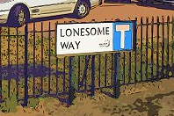

Ostensibly, the purpose of the research was to fill a knowledge gap around the site itself and the needs of the population living there. Over the course of May and June 2011, a number of visits were made to the site both to establish trust and conduct informal interviews and observational research with the gypsy residents. Initial contact was made difficult by the reluctance of those on the site to engage with researchers (especially when it was explained that research was being conducted on behalf of Lambeth Council) and due to the fact that the research team was fed a number of (what turned out to be false) rumours about the site being a potentially dangerous place to visit. Some of these rumours emanated from other Gypsy and Traveller contacts and may have been aimed at deflecting the attentions of researchers rather than having been attempts to smear or defame.

Over the course of the research period we were able to dismiss many of the prevailing assumptions about the people who live on the site as belonging to a generalised mythological and stereotyped view of gypsies and travellers, and perhaps also to a poor past history of engagement with the council and local service providers. Neither the mythology nor the history adequately describes the site today, and both may contribute to negative understandings of the site that have perpetuated problems of engagement.

Today, the site’s population is characterised by the presence of a number of single parent families living on very low incomes and suffering from various physical and social deficits such as worklessness and poorly maintained housing stock. In many respects the needs of the families mirror those of single-parent low-income families living elsewhere, but their relative ‘invisibility’, their insular lifestyle and poor relationship with local and council service providers means that this is a group that could be described as especially socially excluded. As such, many of their needs remain unrecorded and of course, unmet.

Problematic history
A search of publicly available records regarding the site at Lonesome Way reveals that problems of engagement with the people living there on are not new.

Hansard records a parliamentary debate from 1976, before the site was established, in which the then MP for Streatham, William Shelton, argues: “Lambeth has been driven to look closely at a site in my constituency—Lonesome Depot—and now has this site under consideration. It is highly unsuitable for all sorts of reasons… This is a temporary site, with a life of 10 years, providing accommodation for 15 caravans… The site is unsuitable in the view of the residents. Over 2,000 objections have been made to the site… If the site is the best site in Lambeth which the council can find—and it maintains that it is and that it is unsuitable—it proves my contention that there is no suitable land in Lambeth.”

Nonetheless, Lambeth was asked to create the Lonesome Depot Gypsy and Traveller site and it remains to this day. In 1981, problems of integration and acceptance had clearly already manifested in local objections and again William Shelton MP is recorded in Hansard as speaking on the issue in parliament: “In short, the site is highly inappropriate, as I said it would be when it was first suggested. Indeed, all my worst fears and the worst fears of local residents have been proven. This gipsy site disgraces the borough. It is a burden and a disaster for the local community. If accounts are true, it is also the scene of bizarre and cruel happenings… My second indictment is that this site is a disaster to the local community. The RSPCA inspector to whom I spoke, who said I could quote him, said "People live in fear". A local shopkeeper said that he lets the gipsy children help themselves to sweets for fear of what may happen should he stop them. He does not wish his name to be mentioned…
…Guns have been seen on the site by the attendants who work in a park alongside it. Shop windows are broken. The gardens are vandalised. The local park has been vandalised and shut. The local bowling club alongside the site has also been vandalised and shut… the site itself, is a model of mismanagement. Under the Act it has provision for 15 caravans. In fact, on the site are 24 caravans and a permanent house. It has leaking sewage, blocked lavatories, bare electric wires and mountains of rubbish. It has rats. It is a fire risk. It is a health hazard. Mr. Deputy Speaker, you name it, the site has it.”

As we have said, we believe that some of these kinds of accusations amount to no more than rumour and hearsay. Other issues however, such as the reports of rubbish and rats, are ones that we will echo again in this report.

Since these initial representations, there have been scattered records of crime and arrests at the site over the intervening years and a multitude of internet blog posts which allege problems in the community stemming from the site – though none with substantial evidence.

More interesting perhaps, was a recent report produced by the Lambeth Community Consultative Group in April 2010, titled: “Whose Shout?”. This report outlines the results of a piece of work known as “The Engagement Project” for which contact was made with a number of different groups and communities in Lambeth. Although only limited contact was made with the gypsies at Lonesome Depot the report is worth quoting here:

There seems to be very little contact between the statutory authorities and people based at the site. The site and the people who live there seem to have become almost invisible. The street map of the borough used by the Council to mark Community Safety and other features does not include Lonesome Way. The Streatham South Ward map also omits Lonesome Way. (p.24)

This community, and possibly also the housed Roma (mainly of Polish origin) in the borough, do not attend SNP [Safer Neighbourhoods Partnership] meetings and are unlikely to attend public meetings to discuss Community Safety, partly because positive relationships have not been established. (p. 25)

Informal interviews with various stakeholders from Lambeth Council confirm that relationships between council officers (or Lambeth Living officers), and the site, have been problematic – though there is agreement that the situation is less antagonistic now than it has been in the past. For some, there are continued suspicions that crime is an ongoing problem at the site, and this remains a barrier to more positive interventions.

The site today

Lonesome Depot lies on the boundary between Lambeth and Merton council, at the end of a cul-de-sac (Lonesome Way) that juts into the secluded greenery of Streatham Vale Park. At first glance, Lonesome Way appears to be just like any other street in the immediate area. Recently built family homes mask the gypsy and traveller site from the main road; only the grass and trees of the park on the other side of the road suggest anything other than a normal suburban enclave. There is little traffic, save for the occasional car or shabby van, carrying young gypsy women and their children, or men with non-descript loads, to the ‘Depot’.

Rounding the houses introduces a less clement scene. Wooden fences protecting private gardens on the left give way to a high metal barrier marked by graffiti. The tops of caravans can be seen emerging above. A rubbish-strewn, tarmac pavement widens to the right. Ahead, gates and low walls mark the boundaries of two of the Traveller site pitches. One is home to two old caravans, the other to a newer (and considerably more impressive) wooden cabin. Anyone driving up the road or walking to the park gate will do so under the watchful eyes of the site’s residents, fearfully vigilant and suspicious of outsiders.

Leading past these ‘frontline’ homes, a footpath laden with wheelie-bins divides two rows of caravan ‘pitches’. Here, much of the public social life of the site takes place. Children play on bicycles and run from caravan to caravan, women share gossip and cups of tea, and teenagers slouch against the fences and walls.

The site is comprised of 15 ‘pitches’, home, for the most part, to a small and insular community of English Gypsies. Three of the pitches belong to ‘gorgers’ (the Gypsy term for non-gypsies or ‘outsiders’) but they are not spoken of well by the Gypsies themselves.

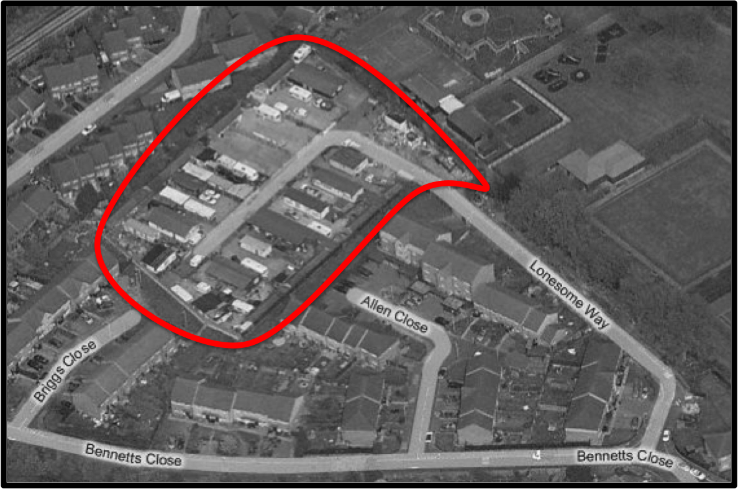

Structures
The site was originally intended to house one caravan on each pitch, but the Gypsies have expanded their living space and several of the pitches now contain more than one caravan. Some of the caravans are mobile, others are semi-permanent homes perched on concrete bricks.

At the back of each pitch there are small, brick, utilities blocks that provide water and gas as well as toilets, and washing facilities. The cost of these blocks, and their maintenance, is paid for by a ground rent that the Gypsies pay to the local housing body.

Each pitch has a boundary fence or wall around it. They vary in style and height – from high garden fences to small brick walls and iron railings and gates. Residents were unclear whether these walls were their responsibility or their landlord’s.

Residents
During research we were not able to make contact with all of the site’s residents. Some were unwilling to talk, others simply were not there during visits. However, it is clear that the site is home to a number of single-parent families. There are approximately 20 children living on the site and they outnumber the adults, who are predominantly women. The women are of differing ages, but a number are in their early 20’s, to some extent looked after by the one or two older women. One or two of the families contain 3 generations.

During the day, people do come and go from the site. Men use the space to park work vans and trucks and make visits to their children. Women and children go back and forth between school, shops and the park.

The site will also play host to temporary and longer-term visitors, mostly other Gypsies, from time to time. They may make extended visits for up to three months. Similarly residents may, on occasion, travel to Ireland or other parts of England. However, the site’s population is relatively stable and permanent. Many of the women describe having lived there for all, or most, of their lives.

The broader picture
Much has been written elsewhere about Gypsies and Travellers in the UK. We will not rehash that material here. However, a broad brush review of the literature reveals that British Gypsies and Travellers are likely to be less healthy (and have a lower life-expectancy), be less educated and live in lower-quality and less stable housing than the general population. They are also more likely to be unemployed, suffer mental health problems, come into contact with the criminal justice system, and commit suicide.

Significantly, they are also very likely to be the victims of ethnic discrimination and abuse.

Some good sources from which to start exploring these issues more deeply include:

- Inequalities experienced by Gypsy and Traveller communities: A review, Sarah Cemlyn et al. Equality and Human Rights Commission, Research Report 12, 2009

- The Health Status of Gypsies & Travellers in England, University of Sheffield, 2004

- Literacy news: the Equality Strategy, National Literacy Trust 2011

- Profiles of prejudice: detailed summary of findings, London: Stonewall, 2003

- The social exclusion of gypsy and traveller children, University of Strathclyde, Sarah Cemlyn et al. 2005

During our research we found nothing to suggest that the Gypsies living at Lonesome Depot, would not fall firmly within these national trends, suffering from the same discriminations, and poor indicators.

Case-studies

There is some value to understanding the life-styles of those who live on the site in order to contextualise the urgency of the list of concerns and needs that will follow. It will allow policy-makers to determine the kinds of problems that may arise in the future if no attempt is made to address current deficits. Case studies can also help to determine actions and responses that are appropriate to the population.

In the following brief stories, names and minor details have been changed to protect the identities of those who took part in the research.

Jamie
Jamie is 30 yrs old. She lives as a single parent with her three boys. They all live in a small trailer, with the boys sharing one room. Jamiehas to sleep on a matress in the front room. Jamie split from her husband after the birth of her third son and now lives on the same pitch as her extended family which includes her Mum, her sister, her cousin and her niece and nephew.

Jamie has lived on the site all of her life apart from one brief period when she went travelling. During her travelling period she did not manage to make close relationships with other travellers and describes the period as being ‘unsuccessful’. Now she prefers to stay more permanently at Lonesome Way.

Jamie left school at 13. She had gone to the local primary school. But had been excluded from school and never enjoyed the time. She says she experienced a lot of bullying and did not want to go back. The legacy of leaving early is that Jamie can only read and write at a very basic level. It also means that Jamie has few friends in the local settled community, though she does maintain one or two relationships.

Jamie is claiming basic benefits though not for housing. She finds it very difficult to live on the money she receives. She says that Lambeth used to provide her money for her children’s school uniforms but since that has been stopped, the cost has put a real strain on her finances. It is important to understand that these kinds of expenses take a real toll, and mean that often she will not eat for herself or will go without new clothes or accessories.
Her gas and electricity are also expensive, because of the price of gas bottles and she complains that her trailer lacks proper insulation meaning that a lot of heat is wasted. Holes and gaps in the windows and in the build of the trailer exacerbate the problem. If Jamie needs money she borrows from direct family. The insularity of the community means that she is not likely to fall prey to loan sharks or informal money lenders.

Jamie looks after her mother as a full time carer and has little spare time outside of her life of family responsibilities. Jamie finds it hard to think of a positive future. She says that it would not be acceptable for her to re-marry, for example. And although currently Jamie's health seems to be quite good she does have sleep problems due to stress. Recently her youngest son had stopped breathing in his sleep on a couple of occasions leaving her worried and anxious.

Lily
Lily is 28 years old. She has lived on the site for fourteen years. She is a single parent with two young children and she also cares for her sister’s child. Lily’s sister suffers from depression, finding it increasingly difficult to cope since the death of their mother, just after the birth of her first child, In effect then, Lily is a carer for both her sister and for all of the children. Lily visits her mothers grave every Sunday with her sister. In this way she believes that she is 'keeping her mothers memory alive'.

Lily has little contact with the children's father but the researchers believed that he did give her money occasionally. He lives elsewhere with his parents. Lily also has contact with her father, who lives off site. If Lily is desperate for money she will go to her father for help.

Lily claims income support, child tax credits and child benefit. She has basic literacy skills but did not stay in school after the age of fourteen as she did not like it and also says that she experienced bullying. Lily says that she may consider living in a house one day, as she is so unhappy at the conditions on the site, but she does not know how she would cope without the support of her community.
-

During research we encountered other stories of financial hardship and difficult living conditions. Families lived with inadequate space, inadequate heating and treacherously ill-maintained out-buildings.

Nevertheless we also found a community with a strong internal identity, albeit not one that would be a typical English Gypsy site. The bonds between the various mothers were strong and, though with limited resources, they did support each other well.

One particularly striking example of the caring role that the women on the site play, is that one of the families seems to have adopted a local child with learning difficulties. The child is mixed-race, but is treated like one of the family. Nonetheless, all maintain a vigorous mistrust and fear of ‘gorgers’, meaning that intervention and help is often not sought, even when needed. The research team felt that the isolation of the community had certainly meant a steady fall in living standards and an increasingly wide relationship gap between state provision and the community needs.

Needs and issues

The case studies above make it clear that the Gypsies face a number of issues on a day-to-day basis. Lack of money and resources prevents them from tackling them. Researchers ran an exercise with the respondents designed to draw out the main issues on the site, from the perspective of the Gypsies themselves.

In many cases, these issues were to do with the material conditions of the site itself. Others, such as lack of access to employment, were longer-term and more structural in nature.

From the point of view of a local authority, it is often tempting to see the various issues as ‘belonging’ to different departments or kinds of service providers within the council structure. However, as we will argue towards the end of this report, solutions which involve the Gypsies having to make multiple applications or appeals to a range of different providers, on their own, is simply likely to leave the problems unaddressed. With this in mind, we would ask policy and decision makers to consider all of the following problems rather than skipping to those that appear, superficially to address only one specific department or job-role.

Engagement with Council services
As highlighted by the ‘Whose Shout?’ report mentioned in the introduction to this report, the Gypsies appear to have minimal involvement and engagement with council services. In a group interview, the Gypsies cited only one person from the council with whom they had regular contact.

One respondent summed up the attitude towards the council: “They always make promises. They say they are going to do this or that, or fix this and fix that… but nothing happens. Nothing ever happens. It’s always the same. They don’t do anything for us.”

The true picture may be a little more complicated Prior to the 2010 General Election, for example, money had indeed been promised by the council for improvements to the Lonesome site. However, these earmarked funds were an early victim of the cuts in local authority spending. The removal of these funds, and by implication the promises of site-improvements, may well have led to the Gypsies’ current perception that promises had been made but not kept.

On a day-to-day basis the Gypsies do in fact use state services. Primary among them is the local school. The children attend the “Lonesome Primary”, which comes under the aegis of Merton Borough Council. Perceptions of the school are very positive and, contrary to reports of Gypsies and Travellers elsewhere, in relation to schools, the children do attend regularly and are encouraged by parents to do so.

Respondents also said that the Gypsy and Traveller liaison worker at the school was very good, providing them often with a single point of contact and help with a wide range of issues. They said that if they had a problem with housing or with the police, their most likely first point of contact would be this school-based liaison worker. Whilst this person may not always be the most appropriate to contact (especially given that they are employed by Merton rather than Lambeth council), it is nonetheless a positive story amongst a more general picture of poor relationships with state services.

Misunderstanding: The Gypsies at Lonesome Depot described their experience of getting services they needed from Lambeth council as, in general, as very ‘hit and miss’. As a rule, they tended to present themselves to state services (such as the job centre) at the point of immediate need rather than before, and would be told to go away and ‘fill in this or that form’. Poor literacy and lack of familiarity with bureaucratic procedures often meant that they would go away without understanding what to do with these various forms, and give up.

It became apparent during the research that their description of not being able to ‘understand’ these kinds of procedures often masked embarrassment and shame. Much more used to sharing information orally and face-to-face, as is customary amongst Gypsies everywhere, they were often unable to negotiate a ‘system’ which required remote contact and forms. Researchers became aware that due to this, some of the families may not have been not receiving the amount of state support to which they were entitled.

Other than the Merton Gypsy and Traveller liaison worker, the Gypsies at Lonesome Depot did not feel that they had a person who was ‘on their side’ to go to for help from Lambeth and lacked support in being able to navigate or negotiate services or entitlements.

Health and well-being
The Gypsies did not complain of a lack of access to healthcare. They said that whilst previous GPs in the area had refused to see them, their current GP was good.

That said, a number of the people we spoke to were in poor health, both physically and mentally. Genty, as we have seen, suffers from a number of different debilitative physical and mental health problems, for example. There is also a general unwillingness to engage with health services (along with other kinds of services) early, meaning that presentation of ill-health is likely to happen when ailments have become more serious.

Health problems may be exacerbated in the long term by a number of different factors:

- Unhealthy eating: the food choices we observed people making were determined solely by price rather than with regard to ‘healthiness’
- Poor environment (damp, cold, unhygienic etc.)
- General lack of information and understanding relating to health and well-being
- General reluctance to pro-actively engage with services that might help in terms of prevention
- Inability to articulate certain kinds of health issues (such as depression)

Crime
The Gypsies were very unwilling to talk to us about crime. For one, the length of time we had for the research did not allow us to build the level of trust needed to address these topics. Second, residents were well aware of the potential for the issue of criminality to be used against them in a discriminatory manner, and were unwilling to add fuel to what is already a fire. And third, the Gypsies saw their relationship with police as poor (this was as much an opinion driven by perceptions of national relations between police and Gypsy and Travellers as a specifically local one – though the site does have a history of dealings with the police itself).

There was some evidence of links between the site and crime in the fact that some of the children’s’ fathers were, at the time of research, serving prison sentences. However, these men were not resident at the site, and though associated with it, would not become residents when released.

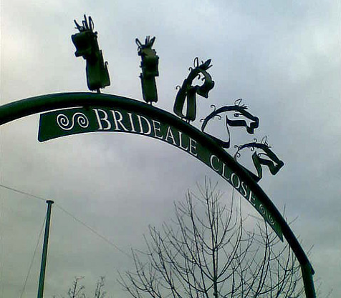
To some extent, the families now living on the site may be suffering discrimination in the present, because of a criminal reputation earned in the past. Whilst it is clear that real police interventions have been required on the site for real incidents, there have also been a lot of rumours and accusations of criminality or vandalism, spread on internet forums for example, that may be based more on prejudice than on truth or evidence.

Whatever the realities, where crime, or at least the perception of crime, presents a barrier to service engagement or service delivery, then the Gypsy families living at Lonesome Depot today are likely to continue to lack the provision they need.

Lighting and vulnerability
Residents on the site complain that one of the issues for them is safety and vulnerability. They do not feel that the site is secure or particularly safe. Outsiders, they say, come up Lonesome Way with impunity, leaving rubbish and invading their space.


One of the issues here is to do with street lighting. The site has a line of lampposts that have been installed – but they do not come on at night. This means that the site is left in relative darkness.
New gateway to Southwark Gypsy and Traveller site at Brideale Close

Second, the site has no physical barrier to entry (such as a gate across the road) and also has no symbolic gateway to mark the boundary and entrance of the site. This means, they say, that fly-tippers come to the site at night and dump rubbish outside the caravans.

Fly-tipping: Residents complain that fly-tippers frequently dump rubbish at the entrance to the site. This rubbish then festers, encouraging vermin and presenting both a fire risk and a hazard to children who will go and play around it.

The local housing body, Lambeth Living, has suggested that the rubbish is actually left by the Gypsies themselves. This is a difficult stand-off, since the residents themselves insist that the rubbish is left by outsiders and is never cleared. They are also clearly distressed by the potential risk to the safety of their children.
Rubbish left at entrance to Lonesome Depot

Poor living conditions
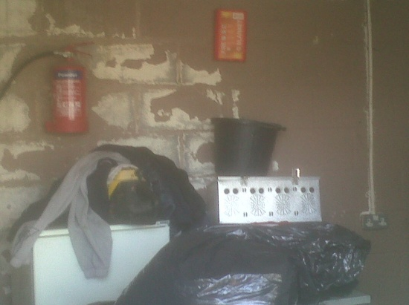
There are a number of issues on the site to do with poor maintenance of the structures and caravans. The quality of the caravans themselves varies, depending on the resources of the family living in them. However, poor electrics, poor heating, damp and damage are common. Since the caravans are privately owned, there may be little that Lambeth council can do to directly improve conditions, however there may also be issues around the access residents have to grants or to finance to improve conditions.

Beyond the caravans, the quality of the ‘sheds’ which are owned and maintained by the local housing body, and for which residents pay a ground rent, is also poor. Water supplies do not work well and residents complain of sewage backing up through the pipes into sinks. They complain that rats frequently overrun the buildings; holes and bad lighting contribute to the problem. They are described as unsanitary and in some cases, unfit for purpose.
Scene inside one of the ‘sheds’
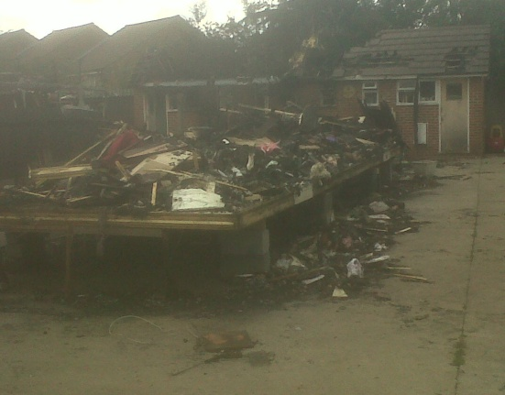

Fire risks, water supplies and sewage
Residents at the site complain of the fire risk posed by the fact that water points are not directly accessible and also by the build up of rubbish around the site.

Residents also worry that there is now only one effective exit from the site (where there used to be two) and that the risk of fire is not only to property but also to the physical safety of the residents themselves.

***STOP PRESS***
Caravan completely destroyed by fire in June 2011

On the 21st of June 2011, fire broke out at Lonesome Way. The pile of rubbish shown earlier in this report caught fire.

The London Fire brigade has reported the incident in the following way:

Three fire engines and around 15 firefighters fought a blaze affecting a large amount of rubbish on Lonesome Way in Streatham Vale, SW16, in the early hours of this morning. Around 20 tones of rubbish was damaged by fire. The Brigade was called at 0059 and the fire was under control at 0240. Crews from Norbury and Mitcham fire stations were at the scene. The cause of the fire is under investigation.

This report is perhaps a little strange, since two caravans, home to families on the site, were also burned down during the incident. The sheds at the back of the pitches were also significantly damaged.

***STOP PRESS***

Residents on the site also complain that there have been drainage and sewage problems on the site for a very long time. Children play in the street and mothers worry about the potential for disease to be spread by overflowing drains and stagnant water.

Many of these concerns echo the fears of the Streatham MP cited at the beginning of this report. Furthermore, since fire and unsanitary conditions on Gypsy and Traveller sites is not a problem unique to Lonesome Depot, it is not unreasonable to say that there has been fair warning of the potential for these problems to end in disaster and tragedy.

Unemployment
As for many, the women we spoke to at Lonesome Depot said that they found it difficult to find work. Some had had temporary jobs in the past working in the local supermarket but currently none of the women had managed to find secure employment.

One young woman described going to the job centre and also connexions (when she was younger) but said they had proved to be unhelpful. She had also gone to the local supermarkets and shops looking for work. She complained that part of the problem was her address: “When I go and try… they give me forms and that… application forms… but I reckon, when they see my address, they know it’s a Gypsy site and they don’t want to know.” This comment brought a chorus of agreement from the other women. We cannot verify this of course, but certainly the Gypsies felt that employers would discriminate against them.

Discrimination and abuse
Whilst relationships with the local school have been a very positive experience which allow local children to become aware of the Gypsies and Lonesome Depot, the residents we spoke to were still concerned that they were the targets of discrimination.

Evidence of this can be seen in local social media, and also in the language used by the MP at the beginning of this report. More generally, in the country as a whole, discrimination against Gypsies and Travellers is widespread. One doesn’t have to look far on the internet to discover open hostility and derogatory language, with seemingly none of the taboos that can protect other ethnic minorities from such open abuse.

For the Gypsies at Lonesome Depot, the sense is more about the effect of discrimination on their chances of finding employment locally, and the feeling that they are being blamed for things they did not do (such as vandalising the bowling club in Streatham Vale Park).

Projects such as the ‘Coat of Many Colours’ film produced by In Toto Theatre and commissioned by Lambeth Children’s’ and young People’s Services, can go a long way toward addressing issues of discrimination locally, but with ongoing media and social media demonisation, issues of discrimination are not likely to subside quickly and could remain a disincentive for the Gypsies at Lonesome Depot to engage with the surrounding community and local service providers.

Cultural insularity
Despite having a long history in Britain and indeed a long history of living in South London and Lambeth, Gypsies and Travellers are not well understood by the general population. Couple this with the desire of many Gypsies and Travellers, including those living at Lonesome Depot, to remain separate from mainstream life and there are now many barriers to be overcome.

Media depictions of Gypsies and Travellers tend to resort to stereotype or sensationalism that exacerbate the problem. The Gypsies at Lonesome Depot, for example, were both pleased and dismayed at the depiction of Gypsy life in “My Big Fat Gypsy Wedding” on ITV. Whilst it showed some things that Gypsies might be proud of, it also, they said, mis-portrayed other aspects of Gypsy life. For example, by sensationalising a Gypsy courtship ritual called ‘grabbing’, the Gypsies at Lonesome Way felt the programme might make Gypsy women and girls more vulnerable to non-Gypsy men, who might feel it was acceptable to make unwanted, aggressive overtures.

It would be far beyond the scope of this report to describe in detail the ‘culture’ of Gypsies and Travellers and unravel the specific variants of cultural institutions present at Lonesome Depot. However, certain things, such as the reticence when dealing with outsiders and especially officers of the state, the stigma attached to making close relationships with ‘gorgers’ (non-gypsies), the desire for families to be formed within Gypsy ethnicities and the strongly gendered roles within families and with regard to work, all need to be understood when making contact with Gypsies and Travellers.

Beyond the notion of ‘traditional’ cultures, there are also shared histories that leave a legacy in terms of Gypsy and Traveller relationships with outsiders. For example, the Gypsies at Lonesome Depot were very well aware of Gypsy and Traveller encounters with police and with housing providers elsewhere. They knew the stories of violent evictions, of children having to watch their homes burning and of police raids on Gypsy and Traveller sites. These shared histories contribute to their understanding of the ways in which they are viewed by various statutory services and by people living around them.

A note on population measurement

There was some hope at the beginning of the study that the ethnographic work would allow us to access settled Gypsies and travellers living in Lambeth and that by doing so, we would be able to make some tentative steps towards understanding the size of the population.

In the event, this proved impossible. The Gypsies living in Lonesome Depot were either unwilling or unable to pass on details of other Gypsies living nearby. They held ethical concerns about passing on details of others who they were not in direct contact with, for the purposes of research.

The little information that we were able to gather was all anecdotal and came in the form of comments like: “There are loads of Gypsies living round here.” Unfortunately ‘round here’ could have meant Merton or Lambeth; perhaps even further afield. We were lucky enough to be able to observe a Gypsy funeral that took place in Merton cemetery and can say with certainty that attendees numbered more than a hundred – but again we can give no indication as to where these people came from.

ESRO has carried out a number of projects for different local authorities in London looking at issues around ‘hard to reach’ populations and measurement. Those London councils that put most resources into Census preparation recognised early that Gypsies and Travellers would prove problematic, both in terms of willingness to complete Census forms and in terms of willingness to identify themselves as Gypsy or Traveller. Nonetheless, it may well be that the first good indication of the size of Lambeth’s Gypsy and Traveller population will come with the results of the 2011 Census.

The “Language Diversity in Lambeth Schools” report produced in 2010 by the Research and Statistics Unit suggests that there might be as few as 32 identified Gypsy pupils in Lambeth schools. But current data-sources like this are not necessarily reliable, given that children and parents may be unwilling to draw attention to their Gypsy or Traveller ethnicity in a public environment; especially in a climate still rife with prejudice. Furthermore, since Gypsy children tend to leave school at 16 (or sometimes not attend at all) – the figures may not give an accurate picture of the true population size.

In line with recommendations ESRO has made to other councils regarding hard-to-count populations, we would suggest that the only way to start getting a handle on certain populations is to have a strong set of relationships with key ‘community partners’ or ‘nodes’ over a sustained period. Building, and delivering on, trust is the only way to begin a dialogue around the importance of filling in forms and surveys and engaging with local services (thereby appearing in public records).

It should be recognised that efforts to really understand and measure a particularly hard-to-reach population may take several years, especially where current relationships are weak or troubled, as is the case here. As a point of comparison, Southwark council set up a Census team involving many different kinds of community leaders and cultural experts (including a Gypsy and Traveller liaison organisation) that actively engaged with hard-to-count populations for more than a year before the Census took place. Even then, there were worries that there would still be a great deal of‘non-responders’ within these populations.

At the time of writing, there is still a need to confirm that the Gypsies at the site did take part in the 2011 Census.

Recommendations

The following list of recommendations was compiled in partnership with the consultation team at Lambeth Council.

Dedicated advocacy role
One of the primary problems, and major barriers to receiving services, for the Gypsies living at Lonesome depot, is the lack of an ongoing and trusted relationship with Lambeth council. The residents are not adept at navigating the various departments or at negotiating their way through applications and representations.

Where relationships do exist, such as with the area manager at Lambeth Living, the officers do not necessarily understand the cultural sensitivities of working with Gypsies and Travellers, and as such are not seen as working in the interests of the residents.

A solution to this problem would be to create a role for a Lambeth Gypsy and Traveller advocate. This could be done in one of two ways:

- A commissioned service from the third sector
- Designating time for an existing Lambeth council officer to be trained in dealing with Gypsies and Travellers, and given a specific role to advocate for Gypsies and Travellers living in the borough

An advocacy role like this would allow both the council and the Gypsies to have a single point of contact for dealing with various issues that arise on the site. Further, an ongoing relationship would allow the advocate to build better relationships with all Gypsies and Travellers living in the borough, creating an environment for better engagement and more involvement in resident surveys and consultations.

The report into social exclusion of Gypsy and Traveller children by Strathclyde University makes similar recommendations:

Sensitive outreach with Gypsy and Traveller communities in non-crisis situations, or at a minimum partnership with more knowledgeable organisations, could promote better communication and facilitate the kind of holistic approach to family support and child protection that is required by government policy. There are a handful of specialist approaches that can build contact and better mutual understanding but these rare posts are vulnerable to cuts. […]

At the service level, training to promote more culturally sensitive responses, more accessible forms of communication, and outreach either directly or in partnership with more specialist services, have all been advocated. This is particularly true in relation to access to better information and advice regarding training and employment courses as well as social security services. (Cemlyn et al., 2005)

Resolution of immediate issues
The Lambeth consultation team have already had constructive conversations with Lambeth Living about moving forward to address the list of concerns (outlined in Appendix 1 of this report). There has already been agreement to tackle some of them, others come up against a genuine lack of funding and/or time.

However, a proper evaluation of the risk of not dealing with problems such as the unsanitary nature of the ‘sheds’ on the site, should be taken into account. If such issues are not dealt with, there should be recognition that there may be further costs down the line in terms of, for example, managing ill-health.

Creating a partnership and dialogue with Merton Council
Although Lonesome Depot is within Lambeth’s borders, the residents make use of Merton Council services and already have contact with a Merton Gypsy and Traveller liaison officer at the local, Merton-run school.

With this in mind, constructive dialogue with Merton Council would be invaluable both to understand the resources that Merton provides and to understand what services the Lambeth Gypsies might be accessing.

Active inclusion
It is important that the residents at Lonesome Depot are included in local resident’s surveys and consultations, to ensure that their voice is better heard within the council. One recent example of where there could have been better engagement was on a recent ‘community consultation’ conducted to explore the regeneration of Streatham Vale Park. Comments in the survey made reference to the Gypsies, but there is little evidence that they were contacted directly, despite living next door to the proposed regeneration site.

In the short-term, such inclusion will have to involve an active and concerted attempt to engage with residents, who may be initially reluctant to engage. However, were the recommendation to create and advocacy role taken up – this would become significantly easier.

It should be noted that it is not enough to simply ask the Gypsies to advocate for themselves at all times. Fears of discrimination, lack of cultural awareness among Lambeth staff and local residents, and a fierce desire for independence among the Gypsies themselves will all hinder their attempts.

Scoping an asset transfer?
Given the current political climate of looking to residents to take a greater role in the management and priorities of local service provision, the idea of an asset transfer scheme could be considered. The idea behind such a scheme would be to provide resources to the Lonesome Depot residents to manage their own site.

Such a project would need to be scoped properly, with proper consideration of issues such as the residents’ ability to manage budgets and sub-contracting arrangements in order to manage their site effectively. It should not be assumed that the residents would, at this point, have the necessary skills, even if the idea seemed initially attractive to them.

Third Sector Sources of Funding
It is clear that the funds to address many of the problems outlined in this report, simply do not exist. The Lambeth consultation team has already identified potential external sources of funding to support Gypsies and Travellers such as the Barbara Cartland Foundation.

Such sources of funding may well prove to be valuable, however it should be recognised that the Gypsies at Lonesome Depot are likely to need support in making applications and in identifying potential funding sources.

Cultural sensitivity in engagement and delivery
There are a number of issues around the need for Lambeth officers dealing with Lonesome Depot to be aware of culturally sensitive issues at the site. For example, male officers may encounter difficulties in engaging deeply with the largely female population of the site. This is due mainly to the taboos around Gypsy women forming relationships with male outsiders.

Other issues, such as the need to build trust over time rather than expecting to be able to solve problems in one visit, or the need for frontline staff in, for example, job centres to understand why the Gypsies may seem unwilling to comply with certain procedures, will also need to be thought about. Even if there are not resources to meet the recommendations outlined above, some level of cultural awareness training for some Council staff will be a pre-requisite for effective engagement in the future.

Appendix 1: Immediate concerns

During research, we ran an exercise with the residents looking at what would constitute their ‘ideal site’. The residents were unwilling or unable to imagine the ‘perfect site’ but instead came back with a list of issues that they felt needed to be dealt with straight away, to bring the site up to a suitable condition for living in. They included:

Rubbish (urgent)
- The site is used by fly-tippers
- Children play in the rubbish
- The rubbish pile has recently caught fire

Fire safety assessment (urgent)
- Access to water
- Fire safety awareness low
- Only one exit from the site – other entrances have been closed
- Poor electrics

Drains and sewage
- Blocked drains and sewage system
- Reports of sewage coming back out of the water supply outlets on the site

Rats
- Residents report an infestation of rats – visible evidence of rats making holes in people’s caravans and in the ‘sheds’
- Health and safety issues

Streetlights
- Lampposts have been installed – but have never worked
- Safety

Privacy
- No clear entrance to the site – site has a bad ‘name’ ‘Lonseome Depot’
- No barrier to entry.
- There is nothing to stop fly-tippers

Utility huts
- The utility huts (‘sheds’) are in a very poor condition
- Fire risk
- Dilapidation
- Water supplies unreliable

Trailers
- Poor state of repair
- Broken windows
- Damp

Postal service
- Random delivery times

Space
- Want two new plots
- Space is there

Rebrand
- The site currently has an unattractive name
- A gate or threshold demarcating the boundaries of the site, with a a new name, would be welcomed



Hansard: HC Deb 16 January 1976 vol. 903 cc886-96
Hansard: HC Deb 29 June 1981 vol. 7 cc675-80
http://www.downloads.lambethcpcg.org.uk/WhoseShout/Whose%20Shout.pdf July 2011
In fact, it is unclear whether any Gypsy men live permanently on the site. Men (and the fathers of the children) come and go during the day. They were largely unwilling to take part in research by sharing personal information.
http://strathprints.strath.ac.uk/835/1/strathprints000835.pdf
A housing officer from Lambeth Living.
http://www.london-fire.gov.uk/LastestIncidentsContainer_21June2011NP1.asp 15/08/2011
http://www.lambeth.gov.uk/NR/rdonlyres/F2AF0A13-2133-4DE4-AD7F-2B2E8B3455AA/0/LanguagediversityinLambethschoolsreport2010.pdf July 2011
This might suggest a population of only 100-200 in total.
There is an existing Gypsy and Traveller liaison (STAG – Southwark Travellers and Gypsies) organisation that has been working in Southwark for several years that could provide a model for this. The commission need not be expensive and could involve a role whereby contact is made with the gypsies for 1 day per week or fortnight.
http://strathprints.strath.ac.uk/835/1/strathprints000835.pdf
Streatham Vale Park: Masterplan Strategy, Groundwork Southwark and Lambeth, 2006 http://www.johmard.com/SVPOA/StreathamValeParkMasterplan.pdf
CLG has released a draft guide to good practice when considering asset transfer, which can be found here: http://atu.org.uk/Document.ashx?ID=308

